Wellbeing support from Swansea Educational Psychology Service for families

Promoting good mental health in children and young people
Everyone has mental health in the same way that everyone has physical health.
Just like our physical health changes over time, so does our mental health. Our physical and mental health can change depending on our lifestyle choices (sleep, nutrition, relaxation and exercise) and personal circumstances.
When we talk about mental health, we are usually talking about our emotions, thoughts and feelings, and the quality of our social connections.
A researcher named Lisa Newland identified that child mental health includes:

Emotional health – for example, resilience (the ability to ‘bounce back’ from difficult experiences and overcome problems) and happiness


Positive attitudes – for example, positive view of life, optimism and life satisfaction

Strong sense of self – for example, self-esteem and a positive personal identity


Healthy social connections – for example, quality relationships with family, friends and teachers

This pack has been made for parents and carers. It contains information, strategies and activities. These strategies and activities can help promote the good mental health of children and young people.

Strategies to promote good mental health in children and young people
Recognise and manage stress
Stress is the way our bodies respond to threats. We all respond differently to stress, and it can change the way we would normally behave. For example, some people may have difficulty sleeping when they are stressed. Some people may have thoughts that are not true, for example “this will never get better”.
Children can also respond to stress in different ways. They may become more clingy, anxious, withdrawn, angry or agitated.
It is important to take steps to recognise and manage your own stress levels and the stress levels of your children.
Making small changes can help to manage stress levels. Making sure that you and your family have a self-care routine can help to manage stress levels. A self-care routine includes
- drinking plenty of water
- getting the right amount of sleep
- taking part in enjoyable family activities
- exercising
- safely spending time outdoors
- Being kind to yourself
- Recognising times when you may be experiencing increased levels of stress

Give them plenty of information

Celebrate children’s curiosity and encourage it! Help them to make sense of the world. Give children the information you think they may need. This will help them to learn more and help get rid of any worries they may have about the unknown. It is important to actively listen to children before offering advice – children may be interpreting things in a different way than we do so we need to try to fully understand what they need more information about.

Play!
Children love having parents who are playful, fun, interested and curious about them. Children learn through play. So much of children’s play prepares them for real life when they grow up. Through play, children can practice their responses and get comfortable with things in a safe space. Play also releases lots of feel-good chemicals in our brains that help us feel calm, steady and connected.
Routines are important
Routines can provide a sense of familiarity, security and predictability to a child’s day that can help to reduce stress. Getting up and going to bed at set times is very important for children’s mental and physical health. Many children benefit from routines being displayed visually though the use of visual timetables. You can make free visual timetables by following this link: https://www.twinkl.co.uk/resource/t-c-081-visual-timetable-for-home and there are many other websites which also offer free visual timetables

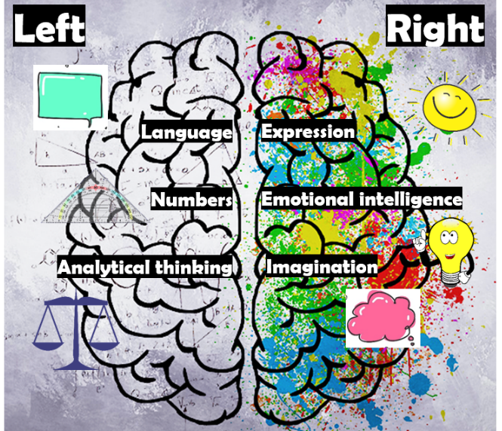
Talk about (and validate) their emotions and feelings
… and share your feelings too!
Encourage children to talk about their emotions and feelings. Talking about feelings connects the analytical left side of the brain to the emotional right side of the brain. When there is a strong connection between the left side of the brain and the right side of the brain, children are better at making sense of their experiences. Talking about experiences will help them to make sense of their feelings and emotions.

The teenage years are a time of significant brain growth, re-structuring and development. Neuroscientific research and understanding informs how we can support young people by helping them to reflect on their thoughts, feelings and experiences.

Talking with children about their emotions and feelings is important because…

- We need to recognise the emotions we experience so that we can manage them
- As children begin to label their emotions and feelings, they can put their feelings into words
- Understanding emotions is important for being able to learn from experiences and cope better in future
- Being able to manage emotions helps children to build and maintain healthy relationships with others. In order to manage emotions, we must be able to recognise and label them!
- As children and young people learn to express emotions in appropriate ways, they are better able to help themselves and others

Help children and young people manage their emotions by…
- Encouraging them to be aware of the emotions they are experiencing
- Encouraging them to think about why they may be feeling that way
- Discussing the best way to express these feelings
- Discussing how other people may be feeling, and how they may feel if they were the other person
These can be challenging for adults, so it will be very challenging for children and young people. However, helping children and young people to manage their emotions in this way may help them to better control their behaviour, cope better with strong emotions and communicate more effectively.


Be careful not to overreact
It is important to show children that you understand how they are feeling, however it is also important not to overreact to their emotions. For example, if children are picked up every time they are scared, they may learn over time to over-react to fear. When children show strong emotions such as fear and anger, it is best to help them to name their emotions or feelings and talk about what might be causing it.
Don’t avoid
It is natural for us to want to protect children from things they find difficult or things they find frightening. This may make things better in the short term, but in the long term it is not helpful. If something is always avoided to make children feel safe, then children may begin to believe that if they avoid things, they will always feel safe. This takes away opportunities to learn that they can cope with unfamiliar situations and things they may not like at first. It is important for children to learn that a little bit of discomfort is okay and that they can cope with new or difficult things.

Let them explore their fears safely
Fear is a very normal part of growing up. With time, children come to figure out that things that seem scary at first become manageable and eventually not scary at all. They begin to realise that they are able to cope.
When children have a genuine fear, it is important to introduce this fear gently. It is important that children feel that they have control when they are introduced to their fears. For example, if a child is terrified by dogs, first introduce them to dogs in books or in a film. Once they are used to this, they may feel safe enough to watch a dog from a window or from behind a fence. This must be done gradually and in small steps, starting with the least scary (a picture of a dog) and working up over time to the fear that upsets them most (patting a real dog).
Acknowledge, praise and encourage good coping behaviours
Recognising, praising and encouraging positive choices and good behaviours will increase the likelihood that children will continue to make good choices and display good behaviours.
Parental encouragement supports child wellbeing by supporting children’s skills and their confidence in those skills.
Don’t give excessive reassurance

Children need reassurance, however if the reassurance is excessive, it can make children feel that there is definitely something to worry about. Excessively reassuring children can take away the opportunity for them to grow their own confidence and their ability to calm themselves. Discuss children’s worries with them and find answers together – can you find answers together about their concerns? It is useful to think with them when solving problems rather than offering up all the answers. It is better to come up with solutions together. Giving children praise and telling them you admire them for starting to think about these things for themselves will help them to grow their own confidence and their ability to calm themselves.

Always say goodbye
It is important for young children to know you will be back when you leave. Leaving while they are distracted might make things easier in the short term, but it may make them shocked and upset when they realise that you are not there. Always saying goodbye helps to build trust from an early age.
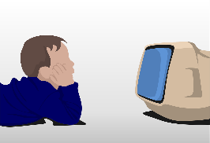
Take time to see what they are watching and reading
If you can, spend time watching your children’s shows and films with them. This will help to understand how they are making sense of what they see and how they may be interpreting the world. Also, children enjoy feeling important and special and they really benefit from having some individual time with parents.
Use positive regulation and relationship
It is important to respond calmly when children’s emotions are elevated. Regulation is what we provide by being with the child and helping them to feel safe even when they are coping with big feelings. When regulation by a trusted and familiar adult is characterised by warmth, and safety and noticing how they are feeling it is positive. When calm, teaching and learning can begin again. Research has found that positive regulation has an effect on children’s behaviours, attitudes, and long-term outcomes in ways that support their wellbeing. It helps to build and maintain important relationships.
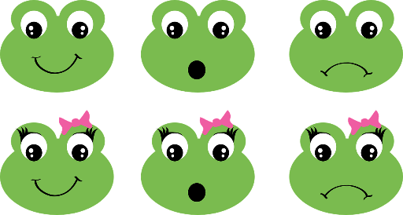
Use the principles of emotion coaching
- Be aware of children’s emotions
- View children’s emotions as an opportunity for intimacy and teaching
- Communicate that you understand and accept the emotions
- Help children to use words to describe how they feel
- Assist children with problem solving
Be mindful of how much time they spend on the internet
The internet has both positive and negative effects on children and young people. When it is used sensibly, it can provide a way for them to discover new things, learn and have fun. However, research has found that too much internet use or inappropriate internet use can risk negatively affecting children and young people’s mental health. Children and young people can be supported to use the internet reasonably and limit the amount of time spent online.
Exercise!
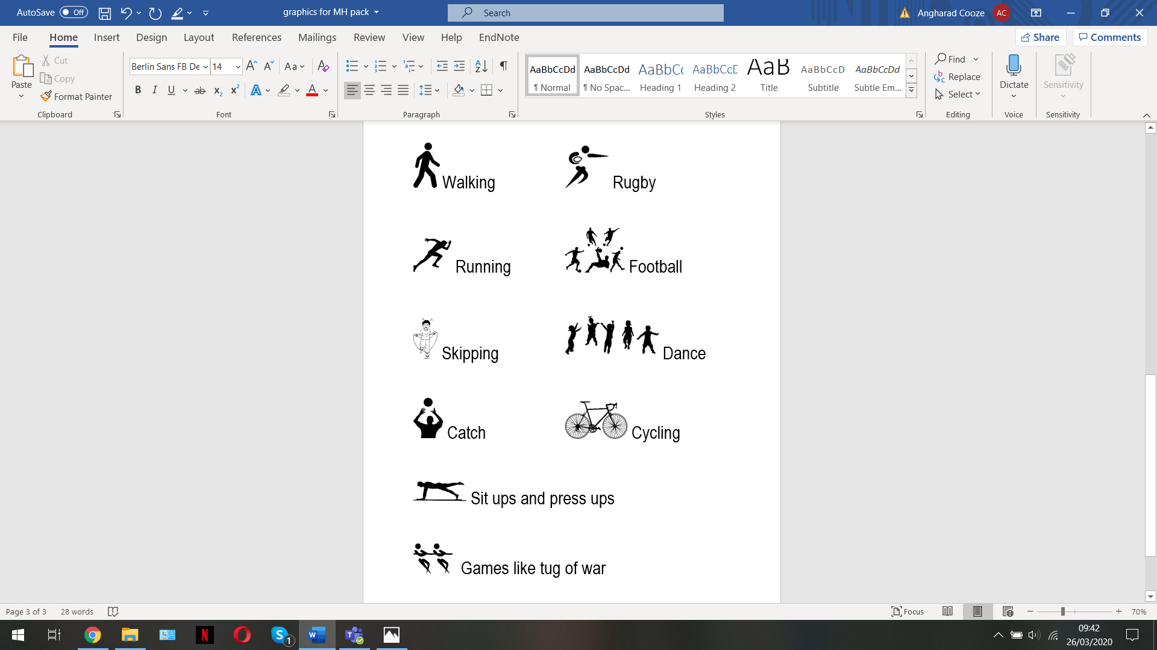
Exercise boosts our psychological wellbeing. Research has found that exercise has a positive effect on the mental health of children, young people and adults. Research has also found that exercise helps with the self-esteem and brain functioning of children and young people.


Develop self-esteem
Self-esteem is concerned with our beliefs about whether we are capable and lovable.
In order to have good self-esteem we must accept ourselves for who we are – we must appreciate all that is positive and unique about ourselves. Importantly, we must also accept our ‘negative’ characteristics.
Our self-esteem has a major impact on how we treat ourselves and others. If we feel unlovable and incapable, we are more likely to treat others poorly. If we believe we are capable and lovable, we are more likely to treat ourselves and others well.
Parents, teachers and friends all have an important impact on children’s self-esteem and how it develops.

Activities for developing self-esteem
- Identify strengths
Examples of strengths include bravery, creativity, curiosity, generosity, enthusiasm, fairness, forgiveness, gratitude, helpfulness, humour, kindness, love of learning, optimism, self-control, teamwork…
Discuss children’s strengths with them – what do they think their strengths are? What do you think their strengths are? They could also identify people they know who may say they have these strengths. For example, they could identify which of these strengths their family would say that they had, which their teacher would say that they had, which their friend might say that they had. They could also be encouraged to discuss which strengths they would like to work on.
This type of activity could be done as a conversation, or it could be done as a mind-map with the name of each strength and a drawing to go with it. You could discuss with them times you have seen these strengths and encourage them to remember times they have shown these strengths.
- All about me
Either discuss or make a book about them. Topics to focus on may include…
Things I can do... Things I’m good at... I’m a good friend when... The best thing about being me is... What my mum/dad/carer/gran/granddad likes about me is... In school my favourite activity is... At home I like to… What I’d never change about myself is... I feel angry when... I feel happy when... I feel sad when... I feel scared when... I feel worried when... I feel peaceful when... I feel important when… My favourite place is…


Use calming strategies
Most behaviours are learned, therefore behaviours may also be unlearned.
It is important to show children we understand how they are feeling – if they feel angry, anxious or upset (or all of these!). It is unhelpful for children to believe that certain emotions are not acceptable or are ‘not allowed’. However, the way children chose to express their feelings can be helped over time, with patience and persistence. Calming strategies may help children to better control strong feelings such as anger.
There are lots of calming strategies. Some may be better in certain situations. Some children may find some more helpful than others. Trying out different calming strategies can help children identify which works best for them.

Examples of calming strategies
- Sit down… Close your eyes… Relax…
Take a deep breath in then let it out very slowly. Repeat this several times.
- Clench all the muscles in your body, starting at your head and working down to your toes. Then work down your body and relax them again, letting all the tension drain away.
- Turtle technique – imagine you have a protective shell to withdraw into and shut yourself off from the situation.
- Take your mind somewhere else that feels safe. For example, imagine yourself curled up in bed or in another favourite place having fun. Try to imagine what you can see, hear, smell and feel.
- Count to ten, or even a hundred! Try counting backwards or counting in twos.
If the mind is concentrating on something else, it cannot focus on the problem.
- Keep repeating a short phrase (in your mind or under your breath) like ‘Cool it!’ or ‘I can get over this.’
- Do some physical activity – running, playing with a ball, punching the air or a pillow.
Physical exercise gets rid of some of the chemicals that build up in your body when you are angry.
- Listen to some music – something that relaxes you or something that makes you happy.
- Remember something funny – a favourite joke or comedy scene.
It is difficult to laugh and be angry at the same time!

