Wellbeing support from Swansea Educational Psychology Service for families

Ideas from Positive Psychology to promote children’s wellbeing
Positive Psychology focuses on thoughts, feelings, and behaviour. Positive Psychology is more interested in personal strengths instead of personal weaknesses.
This pack will focus on two important areas of Positive Psychology - positive emotions and character strengths.
Research has found that focusing on children’s positive emotions and character strengths promotes their wellbeing, and the wellbeing of their families. Wellbeing refers to the quality of people’s lives. It means how we are getting on and how our lives are going.

A huge benefit of Positive Psychology is that it teaches us the power of changing the way we choose to think. A small change in the way people choose to think can improve their wellbeing.
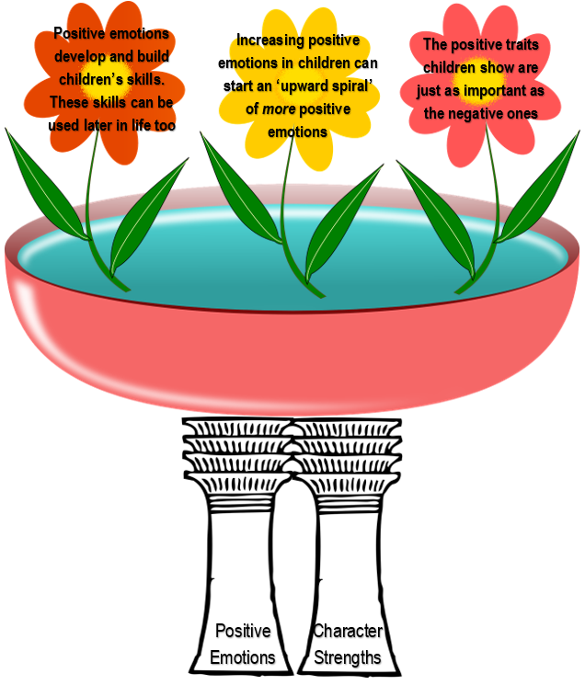
This pack has been designed for parents and carers to use ideas from Positive Psychology to promote their child’s wellbeing.

Positive emotions
Examples of positive emotions are love, joy, curiosity and hope. They help children to improve their wellbeing. Positive emotions also help children when they experience difficult situations.
Examples of negative emotions are anxiety, fear, frustration and anger. When children feel threatened with negative emotions, it can negatively affect their ability to be open to new ideas and build relationships.
A psychologist called Barbara Fredrickson used the example of a water lily to help explain positive and negative emotions. She described how a water lily closes up when the sunlight fades, just like our minds do when positivity fades.
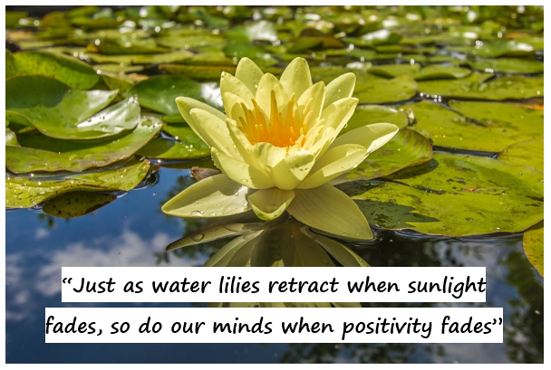


When younger children experience negative emotions, they will want to protect themselves from feeling these negative emotions. This means that they are likely to react without thinking. Once they feel safe again from these negative emotions, they will start to explore the world again through play. Exploring the world through play causes positive emotions children. This can also promote positive emotions in parents, which will promote more positive emotions in children. This happens like a cycle, with children and parents causing each other to experience positive emotions.
Research has found that a parenting style expressing positive emotions like warmth, involvement and affection benefits children’s sense of wellbeing.

Character strengths
Research has found that character strengths exist in everyone.
Making children aware that they have these character strengths will help boost their self-confidence and self-awareness.
Examples of character strengths
 Bravery – acting with strength even when things are difficult or scary
 Creativity – coming up with new ways to think about and do things
 Curiosity – exploring and discovering
asking lots of questions
wanting to learn more about anything and everything
 Enthusiasm – approaching things with excitement and energy
 Fairness – believing all people are important
treating people with respect
 Forgiveness – forgiving people who have done wrong
accepting that people make mistakes
 Gratitude – being aware of and thankful for good things that happen
 Humour – laughing and smiling with others
 Kindness – being generous
enjoying doing good things for others
 Love of learning – enjoying learning new things
 Optimism – expecting the best and working to achieve
 Self-control – controlling emotions and behaviours
thinking before acting
Teamwork – working well with others
The upwards spiral
Research has found that children’s wellbeing can improve when their parents identify and encourage their character strengths.
For children (and especially teenagers), research has found that character strengths are strongly linked with life satisfaction, love, gratitude, hope, and enjoyment.
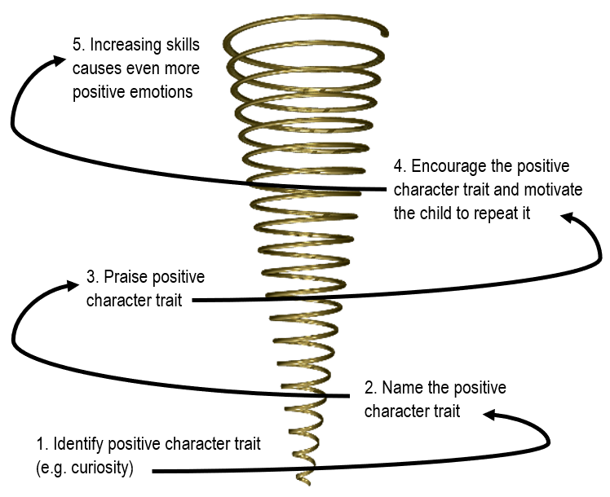

- Character strengths are being discovered and built throughout childhood
- Some character strengths will appear and then disappear; others will keep appearing again and again
- Positive emotions expressed by parents encourage the character strengths of their children

Activities to do with your child
Research found that thinking of three good things a day (or 3 things to be grateful for) improved optimism and happiness six months later.
Making a habit of thinking of good things or things to be grateful for makes us more likely to recognise positive things and events. It helps to change the way we view things.
- Three good things – encourage your child to write down three good things that happen every day, or you could talk about these together instead of writing them down.
- Good news – discuss a good thing that happened together every day. You could do this anywhere – at a mealtime or while you are on a journey somewhere.
- Happiness diary – encourage your child to keep a happiness diary to write down all the things that make them happy. You could write these on a piece of paper and stick them on the fridge or wall and keep adding to them together instead of keeping a diary.
- Best hopes – encourage your child to share their ‘best hopes’ for the day, or for their future. What would they like to do or achieve?
- Positive word tennis – take turns to say one positive word each. Take in turns and keep going until someone can not think of a word. You could do this every week and see how you get better!
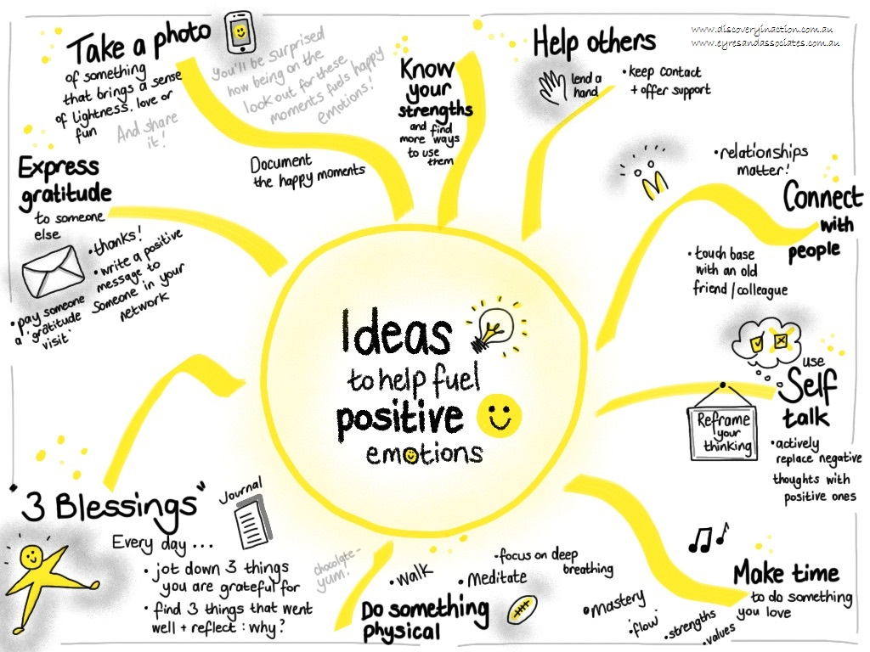
- Funniest moments – think about funny memories and share these. Which positive emotions did you experience?

(This image has been taken from discoveryinaction.com.au/ideas-to-help-fuel-positive-emotions/)

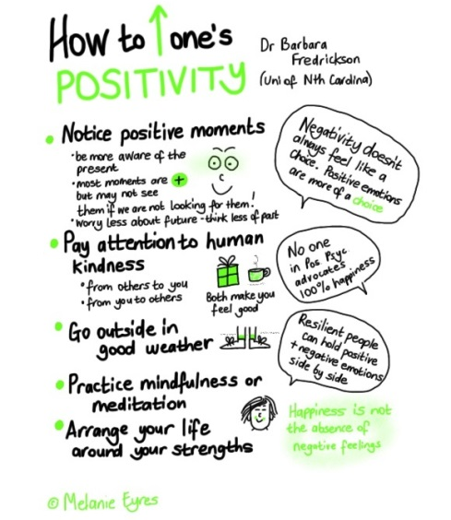

(This image has been taken from discoveryinaction.com.au/ideas-to-help-fuel-positive-emotions/)

