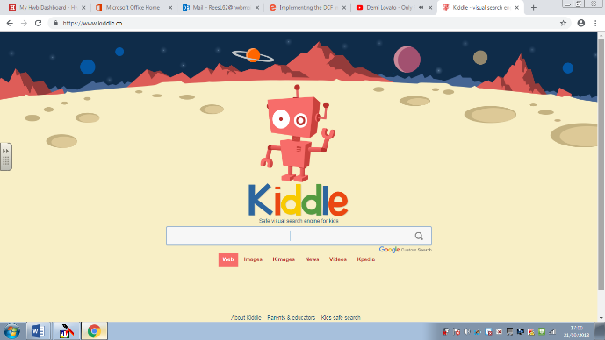  Type in ‘Hwb’. | 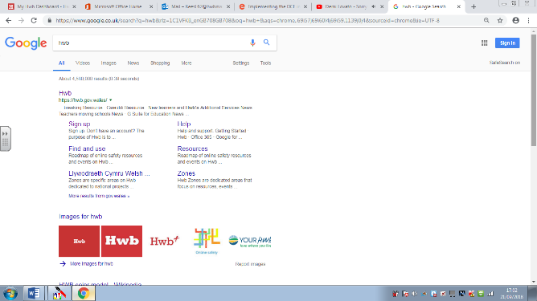  Click ‘Hwb’. | 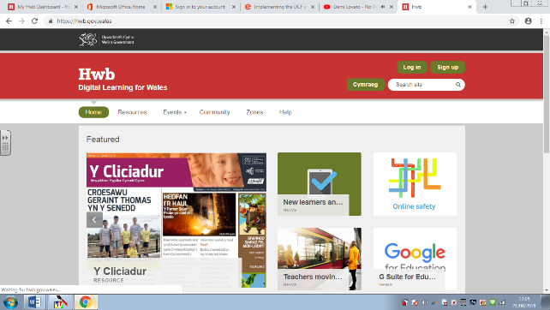  Click ‘Log In’ and type in your details.
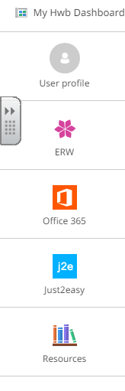  Find and click ‘Just2easy’. | 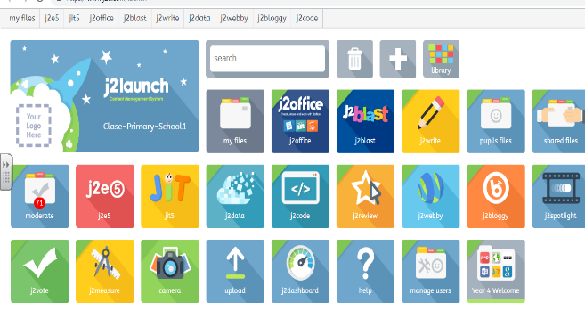  Choose your tool. | 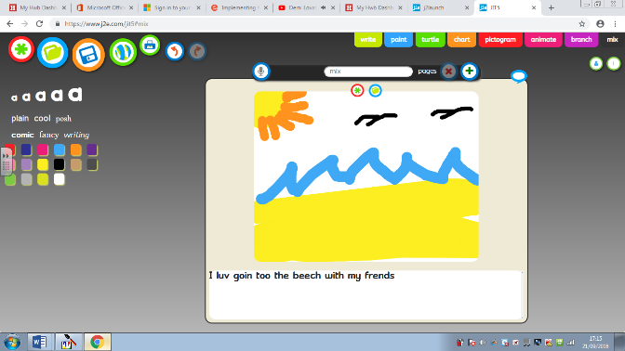  Save your work by clicking the Magic Square. Access by clicking ‘My Files’ on ‘Just2easy’

