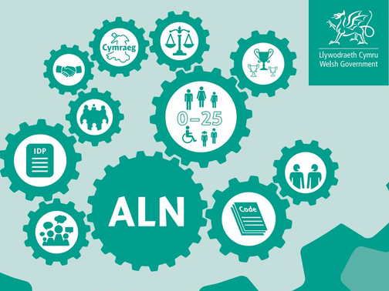 | The aim is to ensure that there are no disputes throughout the process with discussions taking place during the Person Centred Approach.  Individual Development Plan  The process of developing an Individual Development Plan is designed to make sure the views, wishes and feelings for your child/young person are represented. This helps to overcome concerns and prevent disagreements from arising.  Early resolution of any disagreement is best for everyone. If you are unable to agree about a decision or provision, it may be helpful to have independent and impartial help.  I think my child has an Additional Learning Need, who do I speak to?  Speak to your child’s class teacher to outline your main concerns.  - The class teacher will talk to the Additional Learning Needs Coordinator who will determine if your child needs to access further assessments.  - Within 35 days, your school will be in touch to let you know whether they have agreed if your child has an Additional Learning Need.  - If they had identified your child as having an Additional Learning Need, they will let you know how they plan on supporting them. | What should I do if I do not agree with the decision that my child does not have an additional learning need?  - Make an appointment with your schools Additional Learning Needs Coordinator to talk about your concerns.  They will listen to your concerns. You will be given the opportunity to talk about any additional information that you think would be relevant to the decision making process.  If you are still unhappy with their decision, you can request an independent person, such as a caseworker, who will discuss your next steps.  Health Service and Local Authority disputes  If your concerns or disagreements are to do with the Health service and the Local Authority, the Designated Education Clinical Lead Officer (DECLO) appointed by Swansea Bay University Health Board will work together with the Local Authority to try to find a solution.  Information on putting things right can be found at:  https://www.wales.nhs.uk/ourservices/    publicaccountability/puttingthingsright

Additional Learning Needs -
ALN

D: Resolving Disagreements



