Additional Learning Needs – ALN  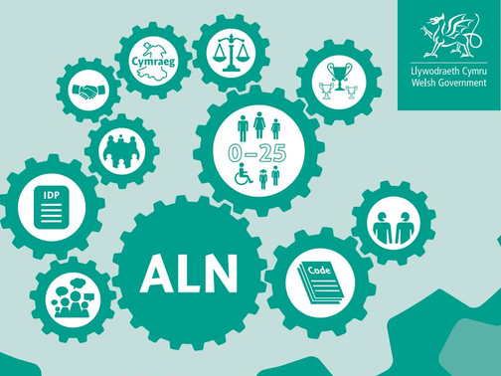  F: Your Right to request that the Local Authority reconsiders an IDP and takes over the responsibility for maintaining it.  Individual  Development Plans (IDPs)  In most cases, your child’s school will be responsible for writing and reviewing your child’s IDPs. These are called school maintained IDPs. In some circumstances, a request can be made to the Local Authority for them to consider transferring these plans over to become Local Authority maintained IDP. | . These requests can come from:  · The child  · The parent  · The school  Local Authority Maintained IDPs  If your child is dual registered, e.g. attends a pupil referral unit (PRU) as well as their mainstream school or Looked After by the Local Authority, then the Local Authority will become responsible for reviewing your child's learning needs and the support that they receive to help them make progress.  When might a case be referred to the Local Authority for consideration  · A school decides that a child or young person no longer has an Additional Learning Need (ALN) and the child or young person or their family are dissatisfied with this outcome.  · A school thinks it is unable to provide the required additional learning provision the child or young person needs.  · A child or young person needs advice and support from specialist services which the school cannot obtain. | Parental requests  If you are dissatisfied with the school’s decision about whether your child has ALN or with the school’s actions around the maintenance of the IDP, you have the right to request the Local Authority to reconsider the schools decision or the content of the IDP.  Before doing this, it would be best to discuss your concerns directly with the school by contacting the ALNCo or Headteacher. If you are still unhappy, you can request the Local Authority to reconsider the school’s decision.  You have 4 weeks to make this request. This time begins from the moment the school notifies you of their decision.  ALN Caseworkers  Swansea Local Authority has a team of caseworkers who can provide you with advice and support if you are unhappy with a school’s decision.  If you think you will need support from this service speak to the schools ALNCo or Headteacher. Alternatively, you can email the caseworker team directly on: caseworker@swansea.gov.uk

