
Clase Primary School
Charging Policy
Vision Statement

To create a happy, healthy learning community where everyone can achieve and succeed.

Mission Statement

We aspire for all our children to become healthy, confident, secure, caring individuals who strive to be the best they can be. They are given every opportunity to achieve their potential, develop a love of learning, foster a sense of belonging, acquire skills to become life-long learners and have the ability to make informed choices.

School Motto

Reaching high, Learning together, Having fun

UN Convention on the rights of children
At Clase Primary School we put the United Nations Convention on the Rights of the Child (UNCRC) at the heart of our school’s planning, policies, practice and ethos. We are a rights-respecting school and teach about children’s rights and also model rights and respect in all its relationships: between teachers / adults and pupils.
The UNCRC underpins our school vision and aims, in particular through Pupil Voice we encourage children to:
- listen to others and respect their ideas
- learn our rights, respect the rights of others and to inform others of children’s rights

Inclusion

Clase Primary School is an inclusive school that aims to meet the needs of all pupils including those with ALN. All children have access to a broad, balanced, stimulating and relevant curriculum whatever their ability or need whilst being encouraged to take responsibility for their own learning, striving to be the best they can. Multi-sensory learning and teaching approaches are used to engage and stimulate all children as learners and ensure their needs are met. Clase Primary School works in line with the Special Educational Needs Code of Practice 2002. We deliver a person-centred package of support in line with the Additional Learning Needs and Educational Tribunal (ALNET) Act (2018). Developing skills, practice and processes in readiness for the implementation of Welsh Government legislation and guidance.
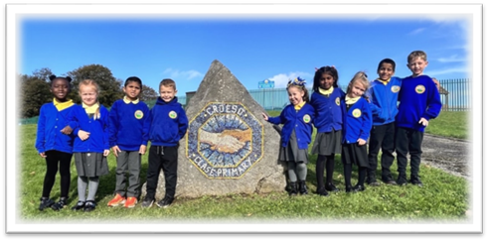

Introduction
Living and growing together, learning that lasts forever
Tyfu a byw’n gytûn, parhau i ddysgu bob un

1.1 All education during school hours is free. We do not charge for any activity undertaken as part
of the National Curriculum, with the exception of some individual or small-group music tuition.

2 Voluntary contributions

2.1 When organising school trips or visits to enrich the curriculum and the educational experience
of the children, the school invites parents/carers to contribute to the cost. All contributions are
voluntary. If we do not receive sufficient voluntary contributions, we may cancel a trip. If a trip goes
ahead, it may include children whose parents/carers have not paid any contribution. We do not
treat these children differently from any others.

2.2 If a parent/carer wishes their child to take part in a school trip or event, but is unwilling or
unable to make a voluntary contribution, we do allow the child to participate fully in the trip or
activity. Sometimes the school pays additional costs in order to support the visit. Parents/carers
have a right to know how each trip is funded. The school provides this information on request.

2.3 The following is a list of additional activities, organised by the school, which require voluntary
contributions from parents/carers. These activities are known as ‘optional extras’. This list is not
exhaustive:
o visits to museums;
o sporting activities which require transport expenses;
o outdoor adventure activities;
o visits to or by a theatre company;
o musical events.

3 Residential visits

3.1 If the school organises a residential visit in school time, or mainly in school time, which is to
provide education directly related to the National Curriculum, we do not make any charge for the
education or travel expenses. However, we do make a charge to cover the costs of board and
lodging. Parents/carers who receive state benefits are asked to make a reduced contribution Act
1999; Child Tax Credit (i.e. Parents who are not in receipt of Working Tax Credit and whose
annual income does not exceed a limit agreed annually) are exempt from payment..
Support under Part IV of the Immigration and Asylum

4 Swimming

4.1 The school organises swimming lessons for all children in Key Stage 2. These take place in
school time and are part of the National Curriculum. We therefore make no charge for this activity.
We inform parents/carers when these lessons are to take place.

5. Parent/Carer consent

5.1 At the beginning of each school year, parents/carers are asked to complete a consent form of
activities throughout the year. This has been introduced at the suggestion of parents, and has
been adopted in an effort to reduce the amount of paper used. Consent forms are kept in a class
file which accompanies the class when participating in activities.

6 Monitoring and review

6.1 This policy is monitored by the governing body, and will be reviewed in three years, or earlier if
Necessary

Review:

 | Name | Signature | Date
Chair of Governors | Steve Avo | 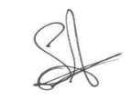 | 14.11.25
Head Teacher | Daniel Jones | 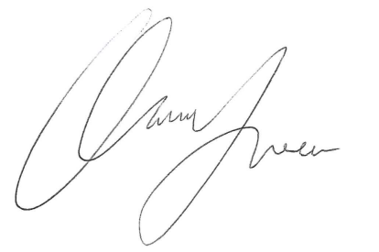 | 14.11.25
Review date  This policy will be reviewed annually | 14.11.26

