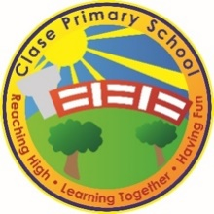
Clase Primary School
Freedom of Information Publication Scheme Policy
Vision Statement

To create a happy, healthy learning community where everyone can achieve and succeed.

Mission Statement

We aspire for all our children to become healthy, confident, secure, caring individuals who strive to be the best they can be. They are given every opportunity to achieve their potential, develop a love of learning, foster a sense of belonging, acquire skills to become life-long learners and have the ability to make informed choices.

School Motto

Reaching high, Learning together, Having fun

UN Convention on the rights of children
At Clase Primary School we put the United Nations Convention on the Rights of the Child (UNCRC) at the heart of our school’s planning, policies, practice and ethos. We are a rights-respecting school and teach about children’s rights and also model rights and respect in all its relationships: between teachers / adults and pupils.
The UNCRC underpins our school vision and aims, in particular through Pupil Voice we encourage children to:
- listen to others and respect their ideas
- learn our rights, respect the rights of others and to inform others of children’s rights

Inclusion

Clase Primary School is an inclusive school that aims to meet the needs of all pupils including those with ALN. All children have access to a broad, balanced, stimulating and relevant curriculum whatever their ability or need whilst being encouraged to take responsibility for their own learning, striving to be the best they can. Multi-sensory learning and teaching approaches are used to engage and stimulate all children as learners and ensure their needs are met. Clase Primary School works in line with the Special Educational Needs Code of Practice 2002. We deliver a person-centred package of support in line with the Additional Learning Needs and Educational Tribunal (ALNET) Act (2018). Developing skills, practice and processes in readiness for the implementation of Welsh Government legislation and guidance.

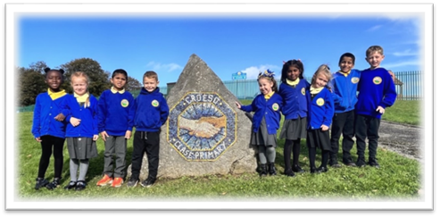

1. Introduction
At Clase Primary School, we are committed to openness and transparency in our operations. We have adopted the Information Commissioner’s Office (ICO) Model Publication Scheme, as required under the Freedom of Information Act 2000 (Section 19).

This scheme sets out the types of information we routinely make available to the public and explains how the information can be accessed.

2. What is a Publication Scheme?
A publication scheme is a guide to the information we make publicly available as a matter of routine. Its purpose is to:
- Promote greater openness and accountability
- Make information easier to access without the need for specific requests
- Reduce the administrative burden of handling individual FOI requests

3. Classes of Information We Publish
We organise the information we publish under the seven classes recommended by the ICO:

1. Who we are and what we do
- Contact information for the school and key staff
- Governing Body details and responsibilities
- School prospectus
- School session times and term dates
- Staffing structure

2. What we spend and how we spend it
- Annual financial reports
- Pupil Development Grant (PDG) expenditure and impact
- Governor allowances and expenses (if claimed)
- Procurement and contracts awarded (where applicable)
- Details of financial audits

3. What our priorities are and how we are doing
- Summary of the School Development Plan (SDP)
- Estyn inspection outcomes
- Performance data summaries (not including pupil-level data)
- Equality objectives and reports

4. How we make decisions
- Minutes of Governing Body meetings (excluding confidential items)
- Admissions policy and decisions (not individual outcomes)
- Consultations and engagement opportunities for parents and the community

5. Our policies and procedures
We make key school policies available, including:
- Safeguarding and Child Protection
- Behaviour and Anti-bullying
- Curriculum and Assessment
- Data Protection
- Complaints Procedure
- Health and Safety
- Charging and Remissions
- Inclusion/ALN
- Staff Code of Conduct
(Full list available on the school website or from the school office.)

6. Lists and registers
- Asset register (available on request)
- Register of pupils (limited access, subject to data protection)
- Any legally required public registers held by the school

7. The services we offer
- Breakfast Club and After School Club details
- Extra-curricular activities
- Information for new parents
- Newsletters and bulletins
- School events calendar

4. How to Access Information
Most of the information in our publication scheme is available on our website:
Printed copies are available on request from the school office. Please contact:
FOI Contact:
School Business Manager
Clase Primary School
Rheidol Avenue Clase Swansea
📞 Tel: 01792 781747
✉️ Email:

5. Charges
- Online access is free of charge.
- Paper copies may incur charges for:
  - Photocopying
  - Printing
  - Postage
A full schedule of charges is available on request.

6. Making a Freedom of Information Request
If the information you are seeking is not included in this publication scheme, you may make a request under the Freedom of Information Act 2000.
Please provide:
- Your name and contact details
- A clear description of the information you are seeking
We will respond within 20 working days.

7. Monitoring and Review
This policy is reviewed annually by the Headteacher and Governing Body to ensure compliance with legal requirements and best practice.

Review:

 | Name | Signature | Date
Chair of Governors | Steve Avo | 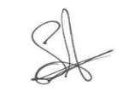 | 14.11.25
Head Teacher | Daniel Jones | 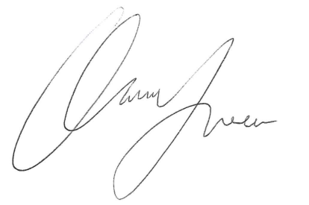 | 14.11.25
Review date  This policy will be reviewed annually | 14.11.26

