
Clase Primary School
Target Setting Policy

(Compliant with the School Performance and Absence Targets (Wales) Regulations 2011)

Vision Statement

To create a happy, healthy learning community where everyone can achieve and succeed.

Mission Statement

We aspire for all our children to become healthy, confident, secure, caring individuals who strive to be the best they can be. They are given every opportunity to achieve their potential, develop a love of learning, foster a sense of belonging, acquire skills to become life-long learners and have the ability to make informed choices.

School Motto

Reaching high, Learning together, Having fun

UN Convention on the rights of children
At Clase Primary School we put the United Nations Convention on the Rights of the Child (UNCRC) at the heart of our school’s planning, policies, practice and ethos. We are a rights-respecting school and teach about children’s rights and also model rights and respect in all its relationships: between teachers / adults and pupils.
The UNCRC underpins our school vision and aims, in particular through Pupil Voice we encourage children to:
- listen to others and respect their ideas
- learn our rights, respect the rights of others and to inform others of children’s rights

Inclusion

Clase Primary School is an inclusive school that aims to meet the needs of all pupils including those with ALN. All children have access to a broad, balanced, stimulating and relevant curriculum whatever their ability or need whilst being encouraged to take responsibility for their own learning, striving to be the best they can. Multi-sensory learning and teaching approaches are used to engage and stimulate all children as learners and ensure their needs are met. Clase Primary School works in line with the Special Educational Needs Code of Practice 2002. We deliver a person-centred package of support in line with the Additional Learning Needs and Educational Tribunal (ALNET) Act (2018). Developing skills, practice and processes in readiness for the implementation of Welsh Government legislation and guidance.

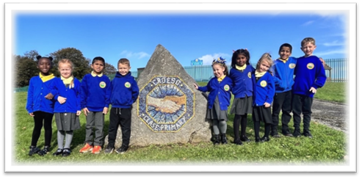

1. Policy Statement
At Clase Primary School, we believe that a school uniform plays a key role in promoting pride, equality, and a sense of belonging within our school community. Our uniform is designed to be affordable, practical, inclusive, and respectful of diversity, in line with Welsh Government expectations.

2. Legal and Policy Framework
This policy is informed by:
- Welsh Government Guidance for Governing Bodies on School Uniform and Appearance Policies
- The Education Act 2002
- The Equality Act 2010
- Human Rights Act 1998
- United Nations Convention on the Rights of the Child (UNCRC)
- Welsh Government’s Well-being of Future Generations (Wales) Act 2015

3. Aims
This policy aims to:
- Set clear expectations for uniform and appearance
- Promote inclusion and respect for protected characteristics
- Ensure affordability and value for money
- Reduce inequality and stigma
- Respect pupil voice and well-being

4. School Uniform Expectations
Everyday Uniform (Example – personalise as needed):
- Blue jumper or cardigan with or without school logo
- Yellow polo shirt or shirt
- Grey or black trousers, skirt or pinafore
- Black shoes or plain black trainers
Optional Items:
- Summer: Blue gingham dress / Grey tailored shorts
- PE Kit: Plain white T-shirt, black/navy shorts or joggers, trainers
Notes:
- Uniform items do not need to be branded – supermarket versions are acceptable
- Logos are optional unless provided for free (e.g. via uniform grant or donation scheme)
- Head coverings for religious reasons are welcomed and should align with health/safety

5. Affordability and Access
- The school seeks to minimise branded items and promote access to affordable alternatives
- Parents can apply for the Welsh Government's School Essentials Grant where eligible
- Clase Primary School runs a pre-loved uniform scheme at our Big Bocs Bwyd shop – donations and collections available termly
- The school consults annually on uniform affordability with parents and the pupil voice group

6. Equality and Inclusion
The school complies with the Equality Act 2010 by ensuring:
- Uniform policy does not disadvantage any pupil based on gender, religion, culture, ALN, or socioeconomic background
- Uniform can be adapted to support pupils with sensory needs or disabilities
- Pupils who identify as transgender are supported to wear uniform items that match their identity

7. Pupil Appearance
We expect all pupils to present themselves neatly and appropriately for learning. However:
- Hairstyles that reflect cultural identity or religious belief are respected
- Makeup, nail varnish and jewellery should be kept to a minimum and safe for school use
- Reasonable adjustments will be made for pupils with specific sensory or health needs

8. Enforcement and Support
- The school works in partnership with parents to encourage adherence
- Pupils will not be excluded, punished or isolated for failing to wear uniform if affordability or other needs are a factor
- Discreet conversations and support will be offered to help families comply
- Staff will apply uniform rules consistently, with sensitivity and equity

9. Pupil Voice
This policy is developed and reviewed with input from:
- Clase Senedd / Rights Respecting group
- Pupil surveys and pupil voice groups
- Feedback on comfort, identity, cost and practicality

10. Monitoring and Review
The governing body will review this policy annually. The review will consider:
- Parental and pupil feedback
- Affordability/accessibility data
- Equality impact and inclusion

Review:

 | Name | Signature | Date
Chair of Governors | Steve Avo | 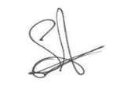 | 14.11.25
Head Teacher | Daniel Jones | 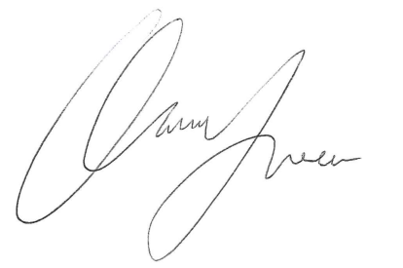 | 14.11.25
Review date  This policy will be reviewed annually | 14.11.28

