
Clase Primary School
Toilet Policy

Vision Statement

To create a happy, healthy learning community where everyone can achieve and succeed.

Mission Statement

We aspire for all our children to become healthy, confident, secure, caring individuals who strive to be the best they can be. They are given every opportunity to achieve their potential, develop a love of learning, foster a sense of belonging, acquire skills to become life-long learners and have the ability to make informed choices.

School Motto

Reaching high, Learning together, Having fun

The Governors of Clase Primary School have adapted this policy from Welsh Government guidance for schools and local authorities on how to provide and maintain good quality, hygienic toilet facilities for learners.

Our aim is to make school toilets accessible, clean and safe by encouraging the adoption of the highest possible standards. We have a duty to educate learners about how to best look after their own health and to respect the facilities provided to them.

This policy document was produced in consultation with pupils, school staff
and governors. The school actively supports the provision of open access to well-maintained, clean, private and safe toilet facilities throughout the school day.

Aims
- To maximise access to learners’ toilet facilities during the day to promote the health, well-being and learning opportunities of all learners.
- To provide good quality toilet facilities throughout the school.

- The school recognises that well-maintained toilet facilities where learners feel comfortable and safe and have open access to throughout the school day, are essential for health, well-being, and learning.
- We value and respect our learners and want them to be able to benefit from good provision and practice.

What do we want to achieve?

- To keep all toilets open and available to learners throughout the school day. While learners can use toilet facilities at break and lunchtimes if they need to, we ensure learners have access at all times. We recognise that toilet needs are highly individual and do not conform to regimental timetables. We recognise that some learners only feel comfortable going to the toilet when others are not around and will allow them to quietly leave the class to use the toilet without adverse comment.
- To ensure that the toilet and washroom facilities are suitable for the range of anticipated users, including learners with disabilities and special needs, with adequate lighting, fixtures and fittings.
- To ensure the toilet and washroom facilities cater for the needs of all learners from ethnic and religious communities, and ensure these needs are met in a sensitive, informed and appropriate manner.
- To ensure that the toilet facilities provide visual and aural privacy for users, ensuring a spare supply of cubicle door locks.
- To ensure that all toilet areas have properly maintained supplies at all times of warm and cold water, liquid soap, hand drying facilities and toilet tissue in dispensers, provided at a convenient height.
- To ensure sanitary disposal units are discretely provided in female cubicles (for girls aged eight and over) and are serviced on a regular basis.
- To implement and maintain an effective toilet cleaning, supervision and inspection regime to ensure proper standards of provision and cleanliness, throughout the school day.
- To locate drinking water supplies and outlets in safe and appropriate locations, and not in toilet areas.
- To supervise the toilets at break and lunchtimes, if learners perceive the need. If learners assume this role, we will train and supervise them to ensure they carry out their duties correctly and do not restrict fellow learners from using the toilets as and when they need to.
- To actively seek the views of the whole-school community in relation to any concerns about toilet provision and access issues (ensuring a child-friendly procedure for pupils to report deficiencies or problems, for example, via the school council) and to respond seriously to these and deal promptly with any problems highlighted by the learners.
- To actively consult and involve the learners in managing the toilets (via the school council or establish a working group).
- To encourage learners to respect the toilets and each other (via the school council, in PSE lessons, in class teacher discussion times) and for learners to establish a Learner Code of Conduct in toilets and washrooms.
- To regularly include toilet management issues in all appropriate school council, staff, parent/carer and governor meetings.
- To provide indoor social areas to discourage toilets from being used for such purposes.
- To implement and maintain annual reviews of the policy to monitor that it is being adhered to and remains relevant.

 | Name | Signature | Date
Chair of Governors | Steve Avo | 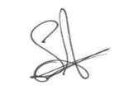 | 14.11.25
Head Teacher | Daniel Jones | 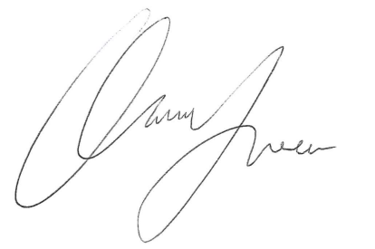 | 14.11.25
Review date | 14.11.28

