
Clase Primary School
Volunteer and Student Policy

Vision Statement

To create a happy, healthy learning community where everyone can achieve and succeed.

Mission Statement

We aspire for all our children to become healthy, confident, secure, caring individuals who strive to be the best they can be. They are given every opportunity to achieve their potential, develop a love of learning, foster a sense of belonging, acquire skills to become life-long learners and have the ability to make informed choices.

School Motto

Reaching high, Learning together, Having fun

UN Convention on the rights of children
At Clase Primary School we put the United Nations Convention on the Rights of the Child (UNCRC) at the heart of our school’s planning, policies, practice and ethos. We are a rights-respecting school and teach about children’s rights and also model rights and respect in all its relationships: between teachers / adults and pupils.
The UNCRC underpins our school vision and aims, in particular through Pupil Voice we encourage children to:
- listen to others and respect their ideas
- learn our rights, respect the rights of others and to inform others of children’s rights

Inclusion
Clase Primary School is an inclusive school that aims to meet the needs of all pupils including those with ALN. All children have access to a broad, balanced, stimulating and relevant curriculum whatever their ability or need whilst being encouraged to take responsibility for their own learning, striving to be the best they can. Multi-sensory learning and teaching approaches are used to engage and stimulate all children as learners and ensure their needs are met.
Clase Primary School works in line with the Special Educational Needs Code of Practice 2002. We deliver a person-centred package of support in line with the Additional Learning Needs and Educational Tribunal (ALNET) Act (2018). Developing skills, practice and processes in readiness for the implementation of Welsh Government legislation and guidance.
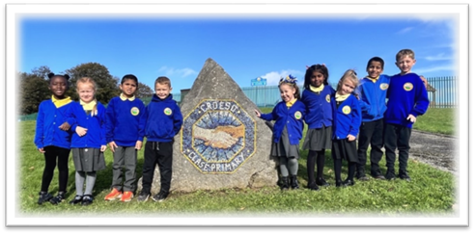

Introduction
Volunteers at our school bring with them a range of skills and experience that can enhance the learning opportunities of children at our school. We welcome and encourage volunteers from the local community.
Our volunteers include:
- Members of the Governing Body
- Parents of pupils
- Ex-pupils
- Students on work experience
- University students
- Local residents
- Friends of the school
The types of activities that volunteers could be engaged in include:
- Hearing children read
- Working with small groups of children
- Working alongside individual children
- Undertaking art & craft activities with children
- Running after-school clubs e.g. cricket, football
- Supporting children with ICT
- Accompanying school visits
- Addressing areas of development highlighted in the School Improvement Plan
- Supporting pupils who have been identified by the Inclusion Team as needing additional support where appropriate
- Providing positive role models
Becoming a Volunteer
Anyone wishing to become a volunteer, either for a one off event such as a school visit or on a more regular basis, usually approaches the Head or Deputy Head directly.
Volunteers should complete the Volunteer Information Sheet (Appendix 1) with their contact details, type of activities they would like to help with, and the times they are available to help.
Before starting to help in school, volunteers should complete the Volunteer Agreement (Appendix 2), which sets out the school’s expectations of volunteers and asks volunteers to confirm they have received a copy of this policy.
Confidentiality
Any concerns that volunteers have about the children they work with / come into contact with should be voiced with the Class Teacher and not with the parents of the child / persons outside school.
Comments regarding children’s behaviour or learning can be highly sensitive, and if taken out of context, can cause distress to the parents of a child if they hear about such issues through a third party rather than directly from the school.
Volunteers who are concerned about anything another adult in the school does or says should raise the matter with the Head or Deputy.
Supervision
All volunteers work under the supervision of the Class Teacher of the class to which they are assigned.
Teachers retain responsibility for children at all times, including the children’s behaviour and the activity they are undertaking.
Volunteers should have clear guidance from the Teacher as to how an activity is carried out / what the expected outcome of an activity is.
Volunteers are encouraged to seek further advice / guidance from the Teacher in the event of any query / problem regarding children’s understanding of a task or behaviour.
Health & Safety
The school has a Health & Safety Policy and this is available on request to volunteers working in the school and is also listed on our website www.Cwm Glasprimaryschool.co.uk under Organisational Policies.
Class Teachers ensure that volunteers are clear about emergency procedures (e.g. fire alarm evacuation) and about any safety aspects associated with a particular task (e.g. using DT equipment / accompanying children on visits).
Volunteers need to exercise due care and attention and report any obvious hazards or concerns to the Class Teacher / Head of School.
Child Protection
The welfare of the pupils is paramount. To ensure the safety of our children, we adopt the following procedures:
- All regular volunteers are given a copy of the Volunteer Policy and asked to sign a Volunteer Agreement
- To ensure the safety of our pupils at all times, all of our regular volunteers must have been cleared by the Disclosure and Barring Service (DBS). A certificate is issued to the individual to produce in school.
- One-off volunteers must be supervised at all times by a member of staff.
Complaints Procedure
Any complaints made about a volunteer will be referred to the Head or Deputy Head for investigation.
Any complaints made by a volunteer will be referred to the Head / Deputy Head.
The Head reserves the right to take the following action:
- To speak with a volunteer about a breach of the Volunteer Agreement and seek reassurance that this will not happen again
- Offer an alternative placement for a volunteer, e.g. helping with another activity or in another Class
- Inform the volunteer that the school no longer wishes to use them
The full Complaints Procedure is set out in the Complaints Policy listed on our Website.
Trips - Volunteer Helper:
School trips are an integral part of learning at our school and sometimes volunteers accompany staff and pupils.
If this is the case and you wish to attend a School Visit the following will apply:
- To be responsible and look after, in equal measure, all of the children in your group
- To stay with your allocated group of children, ensuring that their wellbeing and safety is maintained for the total duration of the school trip
- To ensure that your group keep up with the body of the school visit party, be it walking, entering or exiting from transportation or following speakers for the trip
- To contact your child’s class teacher/member of staff if there are issues with first aid,
- safety and/or behaviour

Monitoring and Review
This Policy has been approved by the Governing Body and will be reviewed bi-annually.
Review:

 | Name | Signature | Date
Chair of Governors | Steve Avo | 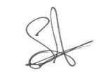 | 14.11.25
Head Teacher | Daniel Jones | 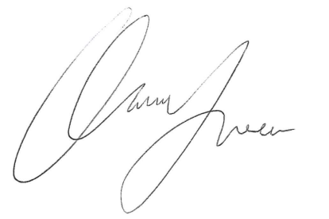 | 14.11.25
Review date | 14.11.28

