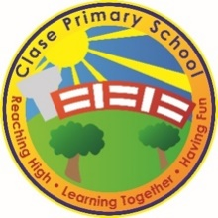
Clase Primary School
Promoting Healthy Eating Policy
Vision Statement

To create a happy, healthy learning community where everyone can achieve and succeed.

Mission Statement

We aspire for all our children to become healthy, confident, secure, caring individuals who strive to be the best they can be. They are given every opportunity to achieve their potential, develop a love of learning, foster a sense of belonging, acquire skills to become life-long learners and have the ability to make informed choices.

School Motto

Reaching high, Learning together, Having fun

UN Convention on the rights of children
At Clase Primary School we put the United Nations Convention on the Rights of the Child (UNCRC) at the heart of our school’s planning, policies, practice and ethos. We are a rights-respecting school and teach about children’s rights and also model rights and respect in all its relationships: between teachers / adults and pupils.
The UNCRC underpins our school vision and aims, in particular through Pupil Voice we encourage children to:
- listen to others and respect their ideas
- learn our rights, respect the rights of others and to inform others of children’s rights

Inclusion

Clase Primary School is an inclusive school that aims to meet the needs of all pupils including those with ALN. All children have access to a broad, balanced, stimulating and relevant curriculum whatever their ability or need whilst being encouraged to take responsibility for their own learning, striving to be the best they can. Multi-sensory learning and teaching approaches are used to engage and stimulate all children as learners and ensure their needs are met. Clase Primary School works in line with the Special Educational Needs Code of Practice 2002. We deliver a person-centred package of support in line with the Additional Learning Needs and Educational Tribunal (ALNET) Act (2018). Developing skills, practice and processes in readiness for the implementation of Welsh Government legislation and guidance.

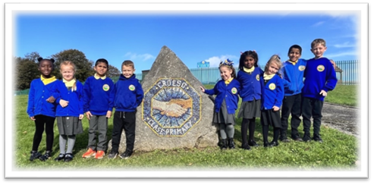

Rationale
Good health is vital and healthy eating, being one of many contributors to this, can influence physical, mental and social well-being. At Clase Primary, the staff are dedicated to helping each child understand the role of healthy eating in achieving good health. We also recognise that healthy eating does not mean having no treats, but means having them at appropriate times. We are proud to be awarded Healthy School Status.

Aims
• To provide opportunities for each child to access knowledge, understanding and skills related to healthy eating so that they may make informed choices.
• To raise awareness of the concepts of ‘healthy eating’ and ‘balanced diet’ and their importance in maintaining good health.
• To develop a positive attitude towards their eating habits.
• To provide opportunities within school to pursue a healthy diet, making healthier choices, easier choices.
• To help the children understand that some foods should be eaten in moderation.
• work in partnership with catering staff to ensure that nutritional standards are implemented by providing attractive, value for money meals that are appropriate to local needs.
• work in partnership to achieve a pleasant and sociable dining experience which enhances the social development of each pupil.
• Involve pupils and parents in decision making.

Curriculum Organisation and Delivery
In Foundation Stage and KS2, healthy eating is addressed through:
• Cross-curricular links
• Discussion between the teacher and pupils and between the pupils themselves
• Whole school projects

Early Years Foundation Stage/Key Stage 2

Subsidised milk is available for children in Foundation Phase. There is a fruit scheme in operation for all children. There is a range of fruit available each day e.g., apples, pears, oranges, bananas, cherry tomatoes and peeled carrots. This provides the children with a daily healthy snack and the social experience of eating together.

Playtime
Children may bring a healthy snack, e.g., fruit or vegetables, to school for morning break. Other items such as sweets, crisps, biscuits etc., are not allowed.

Lunchtime
School lunchtime menus are set by the Local Authority and prepared onsite by the catering staff. Termly theme days are linked to curriculum areas or calendar events. The lunchtime meal offers a choice of foods, which allows the pupils to exercise their knowledge of healthy eating. There is a three week cyclic menu offering a choice of two main meals daily, one of which is suitable for Vegetarians. The menu includes healthy fish options and a range of freshly prepared salads from our salad bar and vegetables. Cheese and crackers, fruit and yoghurt are available daily as options to the main dessert. Brown bread is also available daily. Children are encouraged to try vegetables even if it is a small portion. Guidelines are followed that ensure menus include:
• Reduced fat, sugar and salt
• Increased fibre
• A wide range of freshly prepared salads and vegetables available daily
• Tinned fruit in natural juices
• Fresh fruit and yoghurt

The school recognises the particular value of school meals to children from low-income families. The system for free school meals is actively promoted to parents by the school and a non-discriminatory process is emphasised.
Packed Lunches
For children opt to have a packed lunch, we ask that packed lunches are in a named, airtight container. No sweets, nuts, chocolate bars or fizzy drinks are permitted. Packed lunches should include some fruit or vegetable e.g. piece of fruit or fruit juice, dried fruit, cherry tomato, raw carrot, cucumber wedge. Nuts, sweets, sugary drinks and chocolate should not be included. Diluted fruit juice in a screw top bottle is cheaper and easier to manage than prepared drinks. Water is provided. The school provides a suitable storage area for lunch boxes. Any uneaten food is returned in the children’s packed lunch boxes so the parents and carers can be aware of what the child has eaten whilst at school.

Drinking Water
Water is available throughout the day. All children are encouraged to bring a water bottle to school daily: these are stored in their classrooms and are easily accessible at all times. As well as water, milk is provided every morning for children in early years.

Planning, Recording, Assessment and Reporting
Since many components of healthy eating are also subject linked, the school refers to policy and procedure in PSHE & C, Science, Design & Technology, and Assessment.

Monitoring and Evaluation
Monitoring and reviews of more general aspects of healthy eating will be carried out through observation, and on-going discussion via staff meetings, 4 the School Council. Surveys for parent/carers are another means of seeking opinion about ways to improve this aspect of school life. More formal monitoring of policy and practice is carried out by the PSHE&C Subject Leader, the Senior Leadership Team and the link governor for Healthy Lifestyles.

Equal Opportunities
Healthy eating is for all pupils regardless of gender, race, culture, religion, ability or any special educational need. This will be taken into account when planning the healthy eating curriculum and new initiatives.

Cross Curricular Links
There are opportunities for raising awareness of healthy eating in all areas of school life. Specifically many aspects of healthy eating will be found in the PSHE, Science and Design & Technology schemes of work.

Health & Safety
All activities will be in line with school health and safety policy and DfE guidelines. Most importantly, in recognition of the danger of anaphylactic shock, guidance with regard to the type of snack the children should not bring to school has been issued. We encourage the provision of healthy snack options at school events e.g. fruit kebabs at the summer fair, fruit juices and low-sugar cereal bars at Bike It Breakfast events.

External Links
External agencies are used to promote healthy eating. For example, visits are made by dental nurses in order to teach children about healthy eating. Promotional material is used to further promote good habits in this area.

Review:

 | Name | Signature | Date
Chair of Governors | Steve Avo | 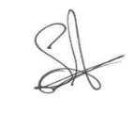 | 14.11.25
Head Teacher | Daniel Jones | 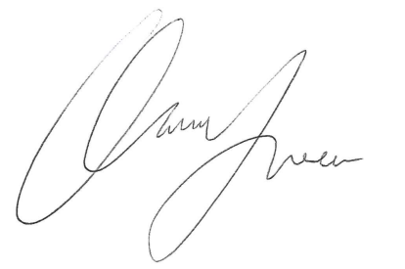 | 14.11.25
Review date  This policy will be reviewed annually | 14.11.26

