
Clase Primary School
Positive Relationship Policy

Vision Statement

To create a happy, healthy learning community where everyone can achieve and succeed.

Mission Statement

We aspire for all our children to become healthy, confident, secure, caring individuals who strive to be the best they can be. They are given every opportunity to achieve their potential, develop a love of learning, foster a sense of belonging, acquire skills to become life-long learners and have the ability to make informed choices.

School Motto

Reaching high, Learning together, Having fun

UN Convention on the rights of children
At Clase Primary School we put the United Nations Convention on the Rights of the Child (UNCRC) at the heart of our school’s planning, policies, practice and ethos. We are a rights-respecting school and teach about children’s rights and also model rights and respect in all its relationships: between teachers / adults and pupils.
- The UNCRC underpins our school vision and aims, in particular through Pupil Voice we encourage children to:
- listen to others and respect their ideas
- learn our rights, respect the rights of others and to inform others of children’s rights

Inclusion

Clase Primary School is an inclusive school that aims to meet the needs of all pupils including those with ALN. All children have access to a broad, balanced, stimulating and relevant curriculum whatever their ability or need whilst being encouraged to take responsibility for their own learning, striving to be the best they can. Multisensory learning and teaching approaches are used to engage and stimulate all children as learners and ensure their needs are met.

Clase Primary School works in line with the Special Educational Needs Code of
Practice 2002. We deliver a person-centred package of support in line with the
Additional Learning Needs and Educational Tribunal (ALNET) Act (2018). Developing skills, practice and processes in readiness for the implementation of Welsh Government legislation and guidance.

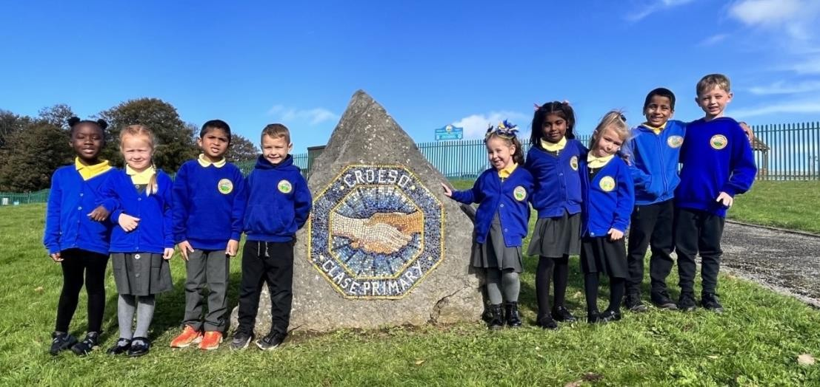

Curriculum, Learning and Experiences

At Clase Primary we recognize

‘there is a range of competences and skills which are foundations for almost all learning and are essential to being able to participate successfully and confidently in the modern world.’

(Successful Futures: 2015)

All Areas of Learning and Experience (AoLE) are underpinned by rich learning experiences which include opportunities to develop numeracy, literacy and digital competency skills.

All subjects encompassed within AoLE are assessed and monitored through the school’s planning and assessment tool, and through listening to learners.

The principles underpinning every AoLE in Clase Primary ensures that the curriculum is:-
authentic: rooted in Welsh values and culture and aligned with four purposes • evidence-based: drawing on the best of existing practice within Wales and from elsewhere, and on sound research
- responsive: relevant to the needs of today (individual, local and national) but also equipping all young people with the knowledge, skills and character for future challenges as lifelong learners
- inclusive: easily understood by all, encompassing an entitlement to high-quality education for every child and young person and taking account of their views in the context of the United Nations Convention on the Rights of the Child (UNCRC), and those of parents, carers and wider society
- ambitious: promoting high expectations and setting no limits on achievement and challenge for each individual child and young person
- empowering: developing capabilities which will allow young people to engage confidently with the challenges of their future lives
- unified: enabling continuity and flow with components which combine and build progressively
- engaging: encouraging enjoyment from learning and satisfaction in mastering challenging subject matter
- based on subsidiarity: commanding the confidence of all, while encouraging appropriate ownership and decision making by those closest to the teaching and learning process
- manageable: recognising the implications for and supported by appropriate assessment and accountability arrangements.
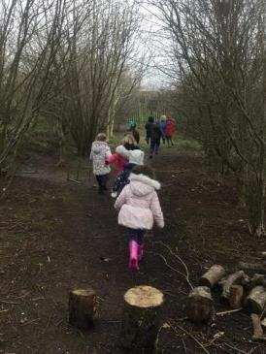
Teachers apply the pedagogical principles identified in Successful Futures when planning their teaching and learning, to ensure that the activities relate directly to the curriculum purposes. (further details found in the Teaching and Learning, and The Curriculum policy)

Teachers and pupils use the “four core purposes” of the curriculum. These will ensure that our pupils will be:-

- ambitious, capable learners who: – set themselves high standards and seek and enjoy challenge – are building up a body of knowledge and have the skills to connect and apply that knowledge in different contexts – are questioning and enjoy solving problems – can communicate effectively in different forms and settings, using both Welsh and English – can explain the ideas and concepts they are learning about – can use number effectively in different contexts – understand how to interpret data and apply mathematical concepts – use digital technologies creatively to communicate, find and analyse information – undertake research and evaluate critically what they find and are ready to learn throughout their lives
- enterprising, creative contributors who: – connect and apply their knowledge and skills to create ideas and products – think creatively to reframe and solve problems – identify and grasp opportunities – take measured risks – lead and play different roles in teams effectively and responsibly – express ideas and emotions through different media – give of their energy and skills so that other people will benefit and are ready to play a full part in life and work
- ethical, informed citizens who: – find, evaluate and use evidence in forming views – engage with contemporary issues based upon their knowledge and values – understand and exercise their human and democratic responsibilities and rights – understand and consider the impact of their actions when making choices and acting – are knowledgeable about their culture, community, society and the world, now and in the past – respect the needs and rights of others, as a member of a diverse society – show their commitment to the sustainability of the planet and are ready to be citizens of Wales and the world
- healthy, confident individuals who: – have secure values and are establishing their spiritual and ethical beliefs – are building their mental and emotional wellbeing by developing confidence, resilience and empathy – apply knowledge about the impact of diet and exercise on physical and mental health in their daily lives – know how to find the information and support to keep safe and well – take part in physical activity – take measured decisions about lifestyle and manage risk – have the confidence to participate in performance – form positive relationships based upon trust and mutual respect – face and overcome challenge – have the skills and knowledge to manage everyday life as independently as they can and are ready to lead fulfilling lives as valued members of society.

At Clase we envisage these core purposes overlapping and developing through rich learning opportunities.

Rationale

It is a primary aim of Clase Primary School that every member of the school community feels valued and respected, and that each person is treated fairly and well. We are a caring community, whose values are built on mutual trust and respect for all. The school relationship policy is therefore designed to support the way in which all members of the school community can live and work together in a supportive way. It aims to promote an environment where everyone feels happy, safe and secure.

At Clase Primary School, we recognise that wellbeing and behaviour are inextricably linked. When children experience safety in their relationships they open up to new learning and reach their full potential; it is therefore vital that wellbeing is placed at the foundation of our school.

We recognise that behaviour is a form of communication and we therefore take responsibility for listening to the needs a child is expressing through their behaviour, whilst setting clear boundaries and expectations. We encourage all stakeholders to recognise both their rights and responsibilities.

Guided by the Cwtsh Approach which uses the principles of Thrive, Trauma Informed practise as well as ACE and attachment Awareness, we will focus on relational connection and regulation first. We will do this by putting relationships at the heart of our approach by truly hearing and responding to our children's voices, in order to create and foster a safe and happy environment where all feel secure and respected.

Our aims:

- To create a positive school culture and climate which is consistent safe and caring that fosters connection, inclusion, respect and value for all members of the school community, promoting strong relationships between staff, pupils and their parents/carers
- Recognising that being ‘fair’ is not about everyone getting the same (equality) but about everyone getting what they need (equity) through appropriate support.

- Staff understand that behaviour is a form of communication of an emotional need (whether conscious or unconscious). With support to self-regulate through unconditional positive regard, pupils can be helped to behave in more socially acceptable/appropriate ways. That relationships are key and that there is
“connection before correction”

- Pupils are provided with excellent role models (alternative attachment figures who provide a secure base and the connection necessary to support correction)

- Staff use PACE and attachment friendly restorative approaches in their interactions with pupils taking a non-judgmental, curious and empathic attitude towards behaviour, responding in a way that focuses on the feelings and emotions that might drive certain behaviour, rather than the behaviour itself. Children and young people with behavioural difficulties need to be regarded as vulnerable rather than troublesome, and we all have a duty to explore this vulnerability.

- Staff have high expectations and maintain boundaries at all times to ensure pupil needs for consistency, predictability and security are met. Changing how we respond to behaviour does not mean having no expectations, routines or structure. In order to help our pupils feel safe, their educational environment needs to be high in both nurture and structure. Our pupils need predictable routines, expectations and responses to behaviour. These must be in place and modelled appropriately, within the context of a safe and caring school environment.

Roles and responsibilities

Managing behaviour relationally: The Cwtsh Approach

‘All of us, from the cradle to the grave, are happiest when life is organised as a series of excursions, long or short, from the secure base provided by our attachment figures’ (Bowlby, 1988)

Consistency lies in the behaviour of adults and not simply in the application of procedure. A truly sustainable consistent approach does not come in a toolkit of strategies but in the whole school community having an agreed understanding of behaviour in the context of neuroscience. The key is to develop a consistency that ripples through every interaction on behaviour. Where children feel heard and treated as valued individuals, they respect adults and accept their authority. Thrive is not an intervention, but a way of being

The role of parents and carers

The school works hard to create positive relationship with parents and carers. We work collaboratively with parents, so children receive consistent messages about how to behave at home and at school.

We explain the behavioural expectations in the school prospectus, and we encourage parents to read these and support them.

We encourage parents to support their child’s learning, and to co-operate with the school, as set out in the home–school agreement. We try to build a supportive dialogue between the home and the school using a variety of methods of communication, which would include dialogue in person/by phone or class dojo and we inform parents immediately if we have concerns about their child’s welfare or behaviour. The school works in partnership to support parents by offering targeted support for identified families.

The role of all staff

Staff will support pupils in developing their ability to:

•Be kind to others in words and actions •Follow instructions from peers and adults.
- Respect other people and their property.
- Move safely and sensibly around the school.
- Challenge themselves in their learning

Staff will do the following to help our pupils meet these expectations:

- Help our pupils to find ways to recognise and manage difficult emotions in an appropriate way supported by adult emotional co-regulation.
- Be emotionally available to help support regulation both within and outside the classroom
- Use calm, well-regulated tone and respectful language appropriate to the needs of the child
- Respond calmly to help pupils become calm (bring our calm to their chaos) • Will manage the transitions throughout the school day so all learning environments feel like safe places
- Will share daily routines, so pupils know what happens next
- Use the Cwtsh approach to understand and support emotional regulation. Use of our schools’ common language e.g. VRFs, PACE, (see appendix)
- Will remain curious and demonstrate the desire to understand a behaviour and what it communicates. (Using WIN – I wonder, imagine, notice)
- Demonstrate unconditional positive regard
- Model positive behaviours and always highlight the behaviour you want to see in positive terms.
- Promote intrinsic motivation by rewarding the process of learning (behaviours for learning).
- Seek both resolution and learning when dealing with incidents. Follow up every time, retain ownership and engage in restorative dialogue with children to repair the rupture at the appropriate time and in an appropriate way, applying natural or logical consequences where appropriate.
- Collaborate with Thrive/Trauma Informed practitioners to develop bespoke plans for identified learners.
- Support all learners to understand the architecture of their brains and gain a better understanding of how feelings can impact our choices and support us to build resilience by promoting a Growth Mindset.

The role of the head teacher

It is the responsibility of the head teacher to implement the school relationship policy consistently throughout the school, and to report to governors, when requested, on the effectiveness of this policy. It is also the responsibility of the head teacher to ensure the health, safety and welfare of all children in the school.

The Headteacher supports the staff by implementing the policy, by setting the standards of behaviour, and by supporting staff in the implementation of the policy
.
The Headteacher has the responsibility for giving fixed-term exclusions to individual children for serious acts of misbehaviour. For repeated, dangerous or very serious acts of anti-social behaviour, the head teacher may permanently exclude a child.

The Headteacher ensures that there is a record incidents of serious behaviour.

The role of governors

The governing body has the responsibility of setting down these general guidelines on standards of behaviour, as set out in the relationship policy and of reviewing effectiveness. The governors support the head teacher in carrying out these guidelines.

The head teacher has the day-to-day authority to implement the relationship policy and ensure standards of behaviour are maintained, but governors may give advise to the head teacher about particular
disciplinary issues. The head teacher must take this into account when making decisions about matters of behaviour.

Recognition and Rewards

The best form of behaviour intervention acknowledges and promotes the positive.
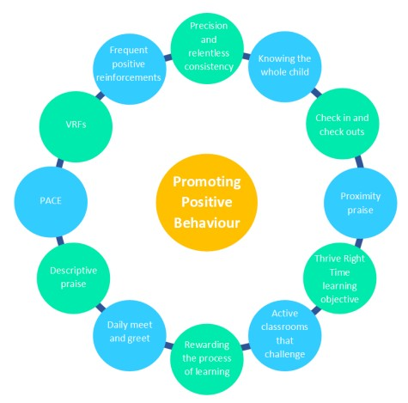

The use of praise in developing a positive atmosphere in the classroom cannot be underestimated. It is the key to developing positive relationships, including with those children who seem the hardest to reach.
We promote a growth mindset when using praise by rewarding the process of learning through awarding dojo points ‘in the moment’. We identify and name the key skills and attributes shown, leading to intrinsic motivation, resilience and lifelong learning. We will reward those children who demonstrate positive behaviours in and around school through:

Verbal Praise and Recognition Value and praise postcards

Stickers Class V Teacher competition

Arwr Dosbarth/Hero of the Week Dojo Points

Headteacher Polite Pupil of the Week Award

Provision for supporting positive relationships in Clase Primary school

Universal Provision - Cwtsh in the Classroom

- Check ins/Check outs
- Meet and greets
- Emotionally available adult
- Safe spaces in classrooms (cwtshy coos)
- Multi-sensory learning provision
- Outside space to physically cool down Class Charters
- Thrive displays sharing Thrive Whole Class Targets and our school’s common language – rooted in VRFs and PACE
- Weekly wellbeing activities built in to planning
- Restorative practise
- Growth Mindset interactive displays
- One Page Profiles
- Cwtsh Ambassadors
- Mindful Toolkits

Y Cwtsh Intervention

- Intensive relational Support
- Supported safe space
- Group or one to one support
- Sibling support
- Cwtsh in the forest
- Cuppa and a Cwtsh
- Bereavement support
- Specialist transition support
- The Haven

Cwtsh for staff

- Whole school support strategies/ books/ resources/ advice / expertise
- Staff wellbeing breakfast
- Staff wellbeing notice board
- Dedicated staff wellbeing page on website
- Bereavement support
- One to one wellbeing mentoring sessions
- Open door drop ins

Interventions for parents – Family Cwtsh

- Parent one to one/group sessions delivering high quality content
- Family relationship building groups e.g. family felting, Cwtsh connection

Cwtsh Professional Friends

- The Exchange Counselling Service
- Camhs School In-Reach
- Early Years Early Help
- Early Help Hub
- Faith in Families - Brighter Futures
- Parent Carer Forum
- SNAP Cymru
- Local Authority Behaviour Support Teacher

Graduated Response for Supporting behaviour

Thinking of a child as behaving badly disposes you to think of punishment. Thinking of a child as struggling to handle something difficult encourages you to help them through their distress. We must be consistent in our application of the rules, codes of conduct, rewards and natural or logical consequences in order to promote a predictable and therefore safe environment.

Relate | Consistent high quality teaching, read the room and redirect using PACE, VRF’s and small acts of kindness
Remind | Reminder of expectations, link to whole class agreed class charters
Final reminder | A clear conversation and ‘final reminder’ delivered privately to the child using the 30 second script to make them aware of their behaviour and clearly outlining the consequences if they continue. Children will be reminded of their unique positive qualities and previous examples of positive choices to separate the behaviour from the child. Praise in Public (PiP) and Remind in Private (RiP).

Consequences

- Consequences which lead to unnecessary shaming or humiliation of the pupil should be avoided. We understand that such approaches are detrimental to the pupil’s self-esteem and wellbeing and can result in increased inappropriate behaviour.
- A consequence may simply be a 2-minute conversation at the end of a lesson.
- Consequences should never involve taking away a previously earned privilege or any intervention time –However, if behaviour has been too extreme to access that privilege or intervention at that time we would encourage the pupil to access that particular reward at a subsequent time/date.
- After a pupil completes catch up, reflection time, or a consequence it is important to repair and restore the staff-pupil relationship.
- Staff should reassure the pupil that the inappropriate behaviour has been dealt with and that all parties will move on and start afresh.
- In addition to consequences pupils will be supported to reflect on their behaviour and be given an opportunity to problem solve for example they may be supported to repair the relationship, replace something that has been broken or tidy a classroom that has been disrupted.

Fixed and permanent exclusions

Clase Primary holds a strong ethos of non-exclusion where possible. However, exclusion may be used on the grounds of health and safety if the behaviour displayed is potentially harmful to themselves or others. Exclusion will only be undertaken with a view to the safeguarding arrangements in place in each individual case.

Only the Headteacher (or the Acting Headteacher) has the power to exclude a child from school. The headteacher may exclude a pupil for fixed periods, for up to 45 days in any school year.

The Headteacher may also exclude a pupil permanently. It is also possible for the head teacher to convert a fixed term exclusion into a permanent exclusion if the circumstances warrant this.

If the Headteacher excludes a child, she informs the parents/ carers immediately giving reasons for the exclusion and informs the parents/ carers how to appeal.

The Headteacher informs the Local Authority (LA) and the Governing Body about any exclusion, whether temporary or permanent. The Governing Body itself cannot exclude a child or extend the exclusion period made by the headteacher.

The Governing Body has a Discipline Committee whose role is set out in strict guidelines whenever a child is excluded from school.

At Clase Primary School, we recognise the complex factors that can impact behaviour. Where behaviour emerges as a consistent challenge for individual pupils, we acknowledge that bespoke intervention should be identified and implemented.

This could include: Cwtch intervention, Proactive plans, risk assessments, Pastoral Support Programme, communication passport, ABC charts, support from Outside agencies.

Intervention should work alongside our whole school approach, aim to support the whole family and promotes sustained connection and a sense of belonging to the school, pupil’s class (learning environment), peers and classroom staff.

Monitoring and Review

The monitoring of this policy is the responsibilities of the Headteacher and Senior Leadership Team. The work of the leadership team also involves supporting colleagues in this area, being informed about current developments and providing strategic direction. This policy will be monitored annually and reviewed in line with the policy review cycle.

 | Name | Signature | Date
Chair of Governors | Steve Avo | 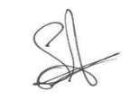 | 14.11.25
Head Teacher | Daniel Jones |  | 14.11.25
Review date | 14.11.26

