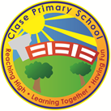
Clase Primary School
Curriculum Design and Planning Policy

Vision Statement

To create a happy, healthy learning community where everyone can achieve and succeed.

Mission Statement

We aspire for all our children to become healthy, confident, secure, caring individuals who strive to be the best they can be. They are given every opportunity to achieve their potential, develop a love of learning, foster a sense of belonging, acquire skills to become life-long learners and have the ability to make informed choices.

School Motto

Reaching high, Learning together, Having fun

UN Convention on the rights of children
At Clase Primary School we put the United Nations Convention on the Rights of the Child (UNCRC) at the heart of our school’s planning, policies, practice and ethos. We are a rights-respecting school and teach about children’s rights and also model rights and respect in all its relationships: between teachers / adults and pupils.
The UNCRC underpins our school vision and aims, in particular through Pupil Voice we encourage children to:
- listen to others and respect their ideas
- learn our rights, respect the rights of others and to inform others of children’s rights

Inclusion

Clase Primary School is an inclusive school that aims to meet the needs of all pupils including those with ALN. All children have access to a broad, balanced, stimulating and relevant curriculum whatever their ability or need whilst being encouraged to take responsibility for their own learning, striving to be the best they can. Multi-sensory learning and teaching approaches are used to engage and stimulate all children as learners and ensure their needs are met.

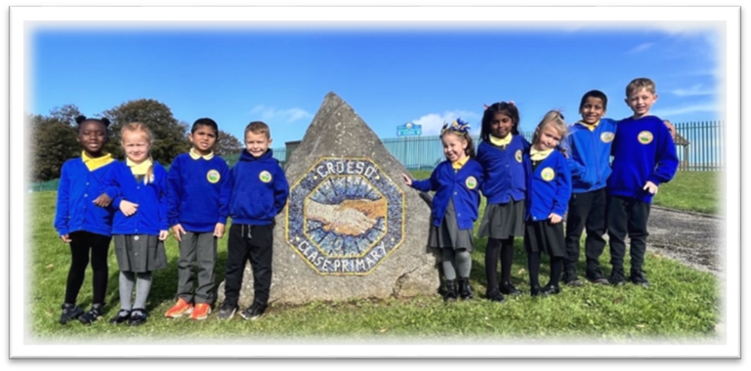

Introduction
“A school’s curriculum is everything a learner experiences in pursuit of the four purposes. It is not simply what we teach, but how we teach and crucially, why we teach it.” (An introduction to the Curriculum for Wales 2022)
At Clase Primary School, our curriculum is meaningful, authentic and relevant to the lives of our pupils. In planning, we consider:
- What should we teach and why?
- How should we teach it?
- How will this support our learners to realise the Four Purposes?
Our curriculum is informed by:
- Our core values
- Our recognition of the Rights of the Child
- Our locality, history and community (Cynefin)
- The interests and aspirations of our pupils

Aims of the Policy
- To provide a clear framework for planning, designing and delivering an ambitious, inclusive curriculum.
- To ensure our curriculum supports progression for all pupils across the continuum of learning.
- To enable staff to work collaboratively and consistently in planning.
- To engage pupils and parents meaningfully in the curriculum.
- To prepare our pupils to become ambitious, capable learners; enterprising, creative contributors; ethical, informed citizens; and healthy, confident individuals.
Curriculum Design Principles
Our curriculum is designed around the following principles:
- Breadth and Balance – ensuring all pupils access a wide range of experiences.
- Relevance – rooted in our local context and meaningful to our pupils’ lives.
- Progression – built across the five progression steps, allowing all learners to move forward appropriately.
- Coherence – concepts, knowledge and skills are connected across AoLEs.
- Authenticity – learning linked to real life, pupil voice, and community engagement.
- Equity – ensuring all pupils, regardless of background, need or ability, have access to rich learning opportunities.
- Creativity and Innovation – enabling inquiry, exploration and independence.

Curriculum Design Process
- The Why – starting with the Four Purposes.
- The What – drawing on the Statements of What Matters, cross-curricular skills, concepts and experiences.
- The How – through the twelve pedagogical principles, authentic contexts, and approaches that motivate and engage learners.

Planning Expectations
Long-Term Planning
- The AoLEs are mapped across a two-year cycle (Cycle A & B).
- Cohorts plan according to the AoLE cluster progression maps.
- Long-term overviews ensure coverage of all six AoLEs and cross-cutting themes (Literacy, Numeracy, Digital Competence, Welsh).
- Experiences such as Expressive Arts projects, visits, Big Bocs Bwyd, and community events are embedded.
Medium-Term Planning
- Developed collaboratively by teaching teams.
- Driven by big questions, inquiry cycles or themes.
- Ensure progression of knowledge, skills and concepts.
- Incorporate pupil voice, real-life contexts, and opportunities for cross-AoLE links.
- Identify formative assessment opportunities and checkpoints.
Short-Term Planning
- Flexible and responsive to learners’ needs.
- Clear learning intentions and success criteria.
- Differentiated to provide challenge and support.
- Includes strategies for TAs and support staff.
- Reflects ongoing assessment and next steps.
Pupil Voice
- Pupils contribute ideas at the planning stage and throughout topics.
- Planning sessions with peers and teachers ensure ownership of learning.
- As pupils progress, they are given increasing responsibility for directing their learning.
Communicating with Parents
- Termly curriculum overviews are shared with parents.
- Parents are invited to workshops, exhibitions, and showcases of learning.
- Family engagement is a core part of our approach, building strong partnerships.
Assessment and Progression
- Assessment is ongoing, formative, and supports learning and next steps.
- Pupil reflection and self-assessment are built into planning.
- Progression steps guide expectations and planning across the continuum.
- Summative assessment is used to inform whole-school planning and reporting.
Inclusion and Equity
We are committed to ensuring all pupils can access and succeed within our curriculum by:
- Meeting the needs of ALN, EAL, and FSM learners.
- Differentiating and adapting teaching approaches.
- Ensuring diversity and equality are reflected in curriculum content.
- Providing additional challenge for more able pupils.
Roles and Responsibilities
- Headteacher/Hannah Humphreys: oversee curriculum design, planning and monitoring.
- AoLE Leads: support colleagues in planning, ensure progression, and provide subject expertise.
- Teachers: plan and deliver in line with this policy, adapting to meet pupils’ needs.
- Teaching Assistants: support delivery, interventions, and pupil engagement.
- Governors: monitor and evaluate the effectiveness of the curriculum.
Enrichment and Community Links
- Learning is enriched through visits, visitors, outdoor learning, expressive arts, and whole-school projects.
- We make strong use of community links (e.g., Big Bocs Bwyd, local heritage, Welsh cultural experiences).
- Partnerships with parents and local organisations bring learning to life.
Monitoring, Evaluation and Review
- SLT review medium-term plans termly to ensure consistency and quality.
- Pupil voice and parental feedback inform curriculum development.
- Annual evaluation of the curriculum ensures it remains ambitious, relevant and responsive.
- Governors receive updates on curriculum implementation and impact.
Policy Review Cycle
This policy will be reviewed every two years (or sooner if there are national or local updates).

 | Name | Signature | Date
Chair of Governors | Steve Avo |  | 14.11.25
Head Teacher | Daniel Jones |  | 14.11.25
Review date  This policy will be reviewed annually | 14.11.26

