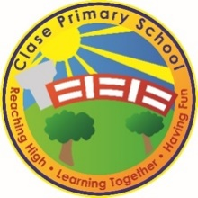
Clase Primary School
Sustainability Policy

(In accordance with Chapter 11 of the Governors’ Guide to the Law)

Vision

To create a happy, healthy learning community where everyone can achieve and succeed.

Mission Statement

We aspire for all our children to become healthy, confident, secure, caring individuals who strive to be the best they can be. They are given every opportunity to achieve their potential, develop a love of learning, foster a sense of belonging, acquire skills to become life-long learners and have the ability to make informed choices.

School Motto

Reaching high, Learning together, Having fun

UN Convention on the rights of children
At Clase Primary School we put the United Nations Convention on the Rights of the Child (UNCRC) at the heart of our school’s planning, policies, practice and ethos. We are a rights-respecting school and teach about children’s rights and also model rights and respect in all its relationships: between teachers / adults and pupils.
The UNCRC underpins our school vision and aims, in particular through Pupil Voice we encourage children to:
- listen to others and respect their ideas
- learn our rights, respect the rights of others and to inform others of children’s rights

Inclusion
Clase Primary School is an inclusive school that aims to meet the needs of all pupils including those with ALN. All children have access to a broad, balanced, stimulating and relevant curriculum whatever their ability or need whilst being encouraged to take responsibility for their own learning, striving to be the best they can. Multi-sensory learning and teaching approaches are used to engage and stimulate all children as learners and ensure their needs are met.
Clase Primary School works in line with the Special Educational Needs Code of Practice 2002. We deliver a person-centred package of support in line with the Additional Learning Needs and Educational Tribunal (ALNET) Act (2018). Developing skills, practice and processes in readiness for the implementation of Welsh Government legislation and guidance.

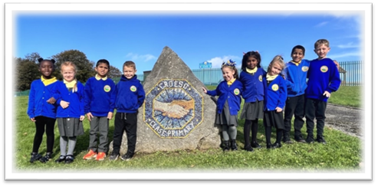

1. Policy Statement
At Clase Primary School, we are committed to promoting sustainable development through our curriculum, school operations, partnerships, and wider school ethos. We aim to equip pupils with the knowledge, skills
and values to become ethical, informed citizens who are active in securing a sustainable future for Wales and the wider world.

2. Legal Framework
This policy is informed by:
- Governors’ Guide to the Law – Chapter 11: Sustainable Development
- Well-being of Future Generations (Wales) Act 2015
- Curriculum for Wales – Four Purposes
- Education (Schools) Act 1992 – Duties of Governing Bodies
- United Nations Sustainable Development Goals (UNSDGs)

3. Definition of Sustainable Development
Sustainable development is defined as:
“Development that meets the needs of the present without compromising the ability of future generations to meet their own needs.”
(Brundtland Report, 1987)
In school, this includes environmental responsibility, social justice, global citizenship, ethical consumption, and wellbeing for all.

4. Aims of the Policy
- To integrate sustainable development and global citizenship across all areas of learning and experience.
- To ensure the whole school community is aware of and acts on sustainability principles.
- To reduce our environmental impact through effective resource management.
- To promote the well-being of pupils, staff and the wider community.
- To encourage critical thinking, ethical action, and pupil-led initiatives.

5. Roles and Responsibilities
Governing Body:
- Ensure that sustainable development is embedded in strategic planning and school policies.
- Monitor the effectiveness and impact of this policy annually.
Headteacher and SLT:
- Lead and model sustainable practices across the school.
- Ensure sustainability is integrated into the curriculum and school development plan.
Teachers and Staff:
- Deliver cross-curricular teaching that embeds sustainability themes.
- Promote ethical and environmentally conscious behaviour.
Pupils:
- Engage in projects and decisions that support sustainability.
- Participate in pupil voice groups (e.g. Eco Council, Rights Ambassadors, School Senedd).
Caretaker and Business Manager:
- Support the reduction of waste, energy use and carbon footprint.
- Promote green procurement and responsible resource use.

6. Key Areas of Action
Curriculum
- Embed Education for Sustainable Development and Global Citizenship (ESDGC) across AoLEs.
- Use real-world projects, critical thinking routines, and enquiry-based learning.
- Promote the Four Purposes with a particular focus on ethical, informed citizens and healthy, confident individuals.
Environment and Operations
- Reduce energy and water usage.
- Increase recycling and reuse.
- Maintain school gardens, wildlife areas, and promote outdoor learning.
- Participate in Eco-Schools or equivalent programmes.
Community and Partnerships
- Work with local businesses, farms, and sustainability organisations.
- Engage parents and the community in green initiatives (e.g. Big Bocs Bwyd, community gardening).
- Promote global citizenship through fundraising, campaigns, and awareness-raising.
School Culture and Ethos
- Model respect for people, place, and planet.
- Encourage responsibility through pupil-led sustainability actions.
- Celebrate achievements in assemblies, newsletters, and displays.

7. Monitoring and Evaluation
- Progress is reviewed through the School Development Plan and Eco-Council/School Senedd reports.
- Feedback from pupil and parent voice activities is gathered annually.
- Quantitative data (e.g. energy usage, recycling rates, attendance) is analysed where possible.

9. Review
This policy will be reviewed annually by the Governing Body in consultation with staff and pupils.

Review:

 | Name | Signature | Date
Chair of Governors | Steve Avo | 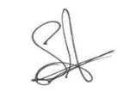 | 14.11.25
Head Teacher | Daniel Jones | 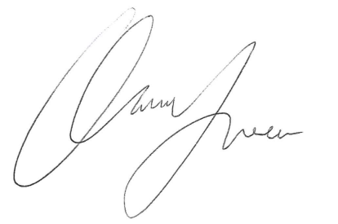 | 14.11.25
Review date  This policy will be reviewed annually | 14.11.26

