
Clase Primary School
Transition Policy Y6 to Y7

Vision Statement

To create a happy, healthy learning community where everyone can achieve and succeed.

Mission Statement

We aspire for all our children to become healthy, confident, secure, caring individuals who strive to be the best they can be. They are given every opportunity to achieve their potential, develop a love of learning, foster a sense of belonging, acquire skills to become life-long learners and have the ability to make informed choices.

School Motto

Reaching high, Learning together, Having fun

UN Convention on the rights of children
At Clase Primary School we put the United Nations Convention on the Rights of the Child (UNCRC) at the heart of our school’s planning, policies, practice and ethos. We are a rights-respecting school and teach about children’s rights and also model rights and respect in all its relationships: between teachers / adults and pupils.
The UNCRC underpins our school vision and aims, in particular through Pupil Voice we encourage children to:
- listen to others and respect their ideas
- learn our rights, respect the rights of others and to inform others of children’s rights

Inclusion
Clase Primary School is an inclusive school that aims to meet the needs of all pupils including those with ALN. All children have access to a broad, balanced, stimulating and relevant curriculum whatever their ability or need whilst being encouraged to take responsibility for their own learning, striving to be the best they can. Multi-sensory learning and teaching approaches are used to engage and stimulate all children as learners and ensure their needs are met.
Clase Primary School works in line with the Special Educational Needs Code of Practice 2002. We deliver a person-centred package of support in line with the Additional Learning Needs and Educational Tribunal (ALNET) Act (2018). Developing skills, practice and processes in readiness for the implementation of Welsh Government legislation and guidance.

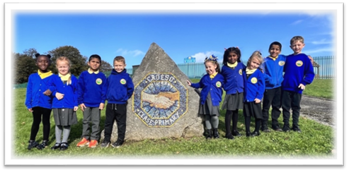

Transition Policy: Key Stage 2 to Key Stage 3
(Prepared in accordance with The Education Act 2002 and the Transition from Primary to Secondary Schools (Wales) Regulations 2006)

1. Policy Statement
This policy sets out the school’s approach to ensuring a smooth and effective transition for pupils moving from Year 6 to Year 7. Our aim is to support each learner academically, socially and emotionally, ensuring continuity in learning and wellbeing.

2. Legal Framework
This policy is written in line with:
- The Education Act 2002
- Transition from Primary to Secondary Schools (Wales) Regulations 2006
- Governors’ Guide to the Law: Chapter 16 – Transition Planning

3. Aims of the Transition Process
- To ensure curriculum continuity and progression in learning
- To support pupils’ emotional, social and pastoral needs
- To provide early and effective support for vulnerable learners (e.g. ALN, LAC, EAL)
- To ensure effective communication and collaboration between schools
- To engage and inform parents and carers throughout the process
- To ensure pupil voice shapes transition activity
- To evaluate and improve transition arrangements annually

4. Scope
This policy applies to:
- All Year 6 pupils on roll at the school
- Pupils transferring to Year 7 at local or agreed secondary schools
- Staff involved in transition (teachers, ALNCos, DSLs, SLT)
- Families and external agencies as appropriate

5. Roles and Responsibilities
Governing Body
- Approves the policy and ensures statutory requirements are met
- Monitors the effectiveness of transition arrangements
Headteacher / SLT
- Leads the strategic oversight of transition
- Ensures effective collaboration with cluster schools
Transition Coordinator
- Manages the transition timeline and communication
- Coordinates pupil profiles and transfer of information
Year 6 Teachers
- Prepare pupils socially, emotionally and academically
- Complete pupil profiles and liaise with secondary staff
ALNCo / Safeguarding Leads
- Identify vulnerable pupils and coordinate additional support
- Ensure safeguarding, ALN and EAL records are shared securely
Secondary School Staff
- Engage in reciprocal visits, induction activities and data handover
- Attend cluster meetings and provide post-transition feedback
Parents and Carers
- Engage with transition opportunities
- Share relevant information and support their child

6. Key Transition Activities
Autumn Term – Year 6
- Cluster transition planning meeting
- Early identification of vulnerable pupils
- Initial communication with parents
Spring Term – Year 6
- Early visits for vulnerable pupils
- Pupil profile information begins
- Y7 staff visit Year 6 classrooms
Summer Term – Year 6
- Induction/transition days at secondary school
- Parent induction evenings
- Final transfer of information, including:
  - Academic data
  - ALN and safeguarding records
  - Social/emotional pupil profiles
Autumn Term – Year 7
- Baseline assessments and bridging units
- Settling-in reviews and feedback to primary schools
- Follow-up support for identified pupils

7. Support for Vulnerable Pupils
We prioritise the needs of pupils who may require additional support during transition. This includes:
- Additional school visits or phased induction
- 1:1 or small group pastoral support
- Transition booklets or visuals
- ALNCo or keyworker support across settings
- ‘Buddy’ systems with older pupils

8. Parental Involvement
- Welcome packs with transition timeline
- School visits and meetings with parents
- Feedback opportunities pre- and post-transition

9. Information Sharing
All pupil information is shared securely in line with Data Protection (GDPR) guidelines. This includes:
- Academic attainment and assessment
- Behaviour and attendance records
- ALN and safeguarding information
- Strengths, challenges, friendship groups

10. Monitoring and Evaluation
The effectiveness of this policy will be reviewed annually in collaboration with the transition cluster group. Monitoring will include:
- Pupil and parent feedback
- Secondary school feedback
- Progress of pupils post-transition
- Vulnerable pupil tracking

11. Review
This policy will be reviewed annually by the governing body and updated in line with statutory guidance and local priorities.

Review:

 | Name | Signature | Date
Chair of Governors | Steve Avo | 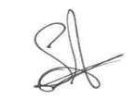 | 14.11.25
Head Teacher | Daniel Jones | 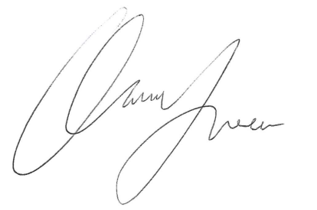 | 14.11.25
Review date  This policy will be reviewed annually | 14.11.26

