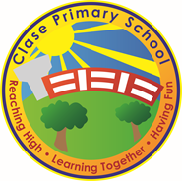
Clase Primary School
Collective Worship Policy
Vision Statement

To create a happy, healthy learning community where everyone can achieve and succeed.

Mission Statement

We aspire for all our children to become healthy, confident, secure, caring individuals who strive to be the best they can be. They are given every opportunity to achieve their potential, develop a love of learning, foster a sense of belonging, acquire skills to become life-long learners and have the ability to make informed choices.

School Motto

Reaching high, Learning together, Having fun

UN Convention on the rights of children
At Clase Primary School we put the United Nations Convention on the Rights of the Child (UNCRC) at the heart of our school’s planning, policies, practice and ethos. We are a rights-respecting school and teach about children’s rights and also model rights and respect in all its relationships: between teachers / adults and pupils.
The UNCRC underpins our school vision and aims, in particular through Pupil Voice we encourage children to:
- listen to others and respect their ideas
- learn our rights, respect the rights of others and to inform others of children’s rights

Inclusion

Clase Primary School is an inclusive school that aims to meet the needs of all pupils including those with ALN. All children have access to a broad, balanced, stimulating and relevant curriculum whatever their ability or need whilst being encouraged to take responsibility for their own learning, striving to be the best they can. Multi-sensory learning and teaching approaches are used to engage and stimulate all children as learners and ensure their needs are met. Clase Primary School works in line with the Special Educational Needs Code of Practice 2002. We deliver a person-centred package of support in line with the Additional Learning Needs and Educational Tribunal (ALNET) Act (2018). Developing skills, practice and processes in readiness for the implementation of Welsh Government legislation and guidance.

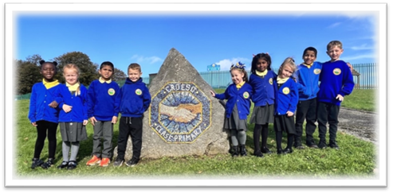

Collective Worship Policy

1. Introduction
At Clase Primary School, collective worship is a central part of our daily life. It provides all learners with opportunities for reflection, community, and moral and spiritual growth in line with the Curriculum for Wales Four Purposes, the Welsh Government’s guidance on collective worship, and the Swansea Agreed Syllabus for Religion, Values and Ethics (RVE).
Our collective worship recognises that the school community includes pupils and staff from a range of faiths and worldviews, and it aims to be inclusive, invitational, and reflective.

2. Aims

Through collective worship, we aim to:
- Foster a sense of community, belonging, and shared values.
- Encourage spiritual, moral, social, and cultural development.
- Provide time for quiet reflection, celebration, and inspiration.
- Support pupils in exploring the big ideas and human questions explored through RVE.
- Promote values consistent with the UN Convention on the Rights of the Child (UNCRC), especially respect, equality, and dignity.
- Provide opportunities to learn about and from Christianity and other world faiths, as well as non-religious philosophical worldviews.
- Reinforce the school’s ethos of being a Rights Respecting and values-based community.

3. Legal and Curriculum Context

Under the Education Reform Act 1988 and Welsh Government Circular 10/94, all schools are required to provide a daily act of collective worship. In Wales, this should be:
- Wholly or mainly of a broadly Christian character, while also being inclusive of other faiths and beliefs.
- Age-appropriate, taking into account the family background, faith traditions, and developmental needs of pupils.
- Reflective rather than instructional, offering space for personal response.

This policy also aligns with:
- The Swansea Agreed Syllabus for RVE (2022)
- The Curriculum for Wales (2022)
- The UNCRC Rights Respecting School framework
- The school’s Values and Assemblies Programme.

4. Organisation

Collective worship takes place every day in accordance with the assembly timetable
Assembly Timetable Nursery to Y6
:
Day | Focus | Lead | Phase
Monday | Rights Respecting Assembly | Deputy Headteacher | Whole School
Tuesday | Christianity / Singing | HH, SJ, EW, WF | Y3–6 / N–Y2
Wednesday | Cymraeg Assembly | RM, MB, KB, LL | Y3–6 / N–Y2
Thursday | Multi-Cultural or Christian Focus | RT, JW, CF, SC | All
Friday | Celebration Assembly – Arwr Dosbarth & Polite Pupil of the Week | Headteacher | Whole School

Assemblies rotate between classroom-based reflection, whole school gatherings, and special festivals linked to the Multi-Cultural Assembly Planner
Multi cultural assembly planner…
.

5. Themes and Content

Themes are carefully planned across the academic year using:
- The Multi-Cultural Assembly Planner (2025–26), ensuring balance between Christianity, major world religions, and non-religious worldviews.
- The Rights Respecting Schools Calendar, ensuring links to key UNCRC articles and global citizenship days.
- The School Value of the Month (e.g. friendship, respect, cooperation, kindness).

Each half term includes assemblies that:
- Explore festivals such as Diwali, Eid, Hanukkah, Christmas, Vesak, and Vaisakhi.
- Link stories and teachings from faiths and philosophies to moral values.
- Incorporate symbolic actions (e.g. friendship trees, peace candles, justice scales) that encourage pupil participation and reflection.
- Provide time for music, prayer, stillness, or thought suitable for all.

Special events include:
- Harvest, Christmas, and Easter services (broadly Christian in character).
- Multi-faith celebration weeks.
- Class and pupil-led assemblies linked to topic work and RVE enquiry.

6. Inclusivity and Rights

Collective worship at Clase Primary is:
- Inclusive – open to all regardless of faith or belief.
- Respectful – affirming diversity and encouraging curiosity about difference.
- Voluntary in response – pupils may engage through thought, prayer, song, or quiet reflection.
Parents have the legal right to withdraw their child from collective worship, though we encourage dialogue to ensure understanding of its inclusive intent.

Assemblies reinforce UNCRC rights, particularly:
- Article 12 – Right to be heard
- Article 14 – Right to freedom of thought, belief, and religion
- Article 29 – Right to education that develops respect for others
- Article 31 – Right to rest, play, and cultural participation

7. Leadership and Pupil Voice

Collective worship is led by:
- Headteacher, Deputy Headteacher, staff, and visiting faith/community leaders.
- Pupil voice groups such as the Clase Senedd contribute ideas and occasionally lead reflections.
- Pupils in Years 5–6 regularly assist in planning and leading assemblies around moral or rights-based themes.

8. Monitoring and Evaluation

The effectiveness of collective worship is reviewed termly by the Senior Leadership Team and RVE lead through:
- Observations of assemblies.
- Pupil and staff feedback.
- Links to Curriculum for Wales (Ethical, Informed Citizens).
- Evidence of pupil participation and impact on school ethos.
Findings are reported to governors annually.

9. Special Considerations
- Worship is adapted to be developmentally appropriate across Nursery–Y6.
- Themes are aligned with the school calendar, local community, and national days of significance (e.g. Anti-Bullying Week, World Religion Day).
- Opportunities are taken to celebrate Welsh identity, language, and culture, in line with Cymraeg assemblies.

10. Review
This policy will be reviewed every two years, or sooner if new statutory guidance or local authority expectations are issued.

 | Name | Signature | Date
Chair of Governors | Steve Avo | 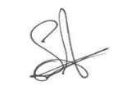 | 14.11.25
Head Teacher | Daniel Jones | 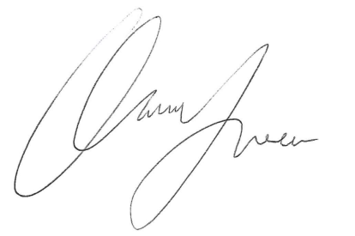 | 14.11.25
Review date  This policy will be reviewed annually | 14.11.27

