
Clase Primary School
E-Safety Policy

(Aligned with Swansea’s Principles to Promote Learning, 2025)

Vision Statement

To create a happy, healthy learning community where everyone can achieve and succeed.

Mission Statement

We aspire for all our children to become healthy, confident, secure, caring individuals who strive to be the best they can be. They are given every opportunity to achieve their potential, develop a love of learning, foster a sense of belonging, acquire skills to become life-long learners and have the ability to make informed choices.

School Motto

Reaching high, Learning together, Having fun

UN Convention on the rights of children
At Clase Primary School we put the United Nations Convention on the Rights of the Child (UNCRC) at the heart of our school’s planning, policies, practice and ethos. We are a rights-respecting school and teach about children’s rights and also model rights and respect in all its relationships: between teachers / adults and pupils.
The UNCRC underpins our school vision and aims, in particular through Pupil Voice we encourage children to:
- listen to others and respect their ideas
- learn our rights, respect the rights of others and to inform others of children’s rights

Inclusion

Clase Primary School is an inclusive school that aims to meet the needs of all pupils including those with ALN. All children have access to a broad, balanced, stimulating and relevant curriculum whatever their ability or need whilst being encouraged to take responsibility for their own learning, striving to be the best they can. Multi-sensory learning and teaching approaches are used to engage and stimulate all children as learners and ensure their needs are met.

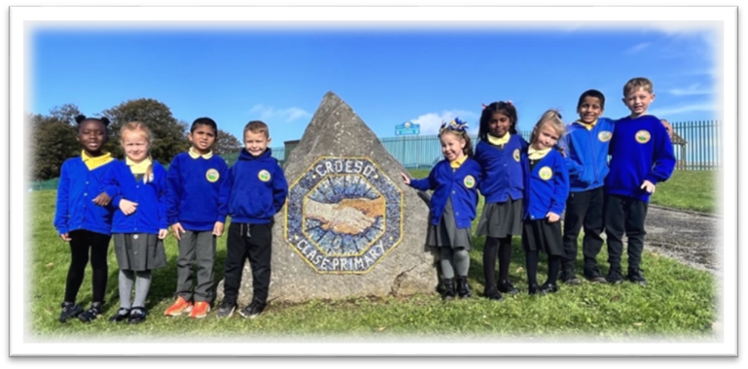

1. Purpose and Scope
This policy ensures that all members of Clase Primary School use digital technologies safely, responsibly, and respectfully. It applies to pupils, staff, governors, parents, and visitors when accessing school systems, devices, or online platforms, whether on‑site or remotely. The policy supports our commitment to safeguarding and promoting the welfare of all learners in digital environments.
2. Policy Links
This document complements and should be read alongside:
- Acceptable Use Policy (AUP)
- Safeguarding Policy
- Anti‑Bullying Policy
- RSE Policy
- Data Protection (GDPR) Policy
Together, these policies form the school’s digital‑safeguarding framework.
3. Leadership and Responsibilities
- Headteacher / Designated Safeguarding Lead (DSL): overall responsibility for online‑safety strategy, incident management, and liaison with external agencies.
- ICT Coordinator / Digital Competence Lead: oversees curriculum delivery, technical safety measures, and staff training.
- Staff: model safe online behaviour, follow the AUP, and report concerns promptly.
- Pupils: use technology responsibly, respect others online, and report anything that causes discomfort or concern.
- Parents / Carers: reinforce safe online practices at home and engage with school guidance.
4. Education and Training
E‑safety education is embedded within the Digital Competence Framework and RSE curriculum. Pupils learn about privacy, cyberbullying, social‑media conduct, and digital wellbeing through age‑appropriate lessons and assemblies. Staff receive annual training on online‑safety procedures and emerging risks. The school promotes national initiatives such as Safer Internet Day and shares guidance with families through newsletters and workshops.
5. Technical and Procedural Safeguards
Clase Primary School maintains secure filtering and monitoring systems provided by the Local Authority and Hwb. Access to online services is password‑protected and monitored. Data is handled in accordance with GDPR. The school ensures that all devices are updated regularly and that pupils understand the importance of protecting personal information online.
6. Incident Management
All online‑safety concerns, including cyberbullying, inappropriate content, or data breaches, must be reported immediately to the DSL or Headteacher. Incidents are logged, investigated, and, where necessary, referred to external safeguarding partners. Evidence is preserved securely, and confidentiality is maintained throughout. Disciplinary measures follow the school’s Behaviour Policy.
7. Review and Evaluation
This policy will be reviewed annually by the Headteacher and ICT Coordinator, or sooner if new guidance or legislation arises. Evaluation will align with 360 Safe Cymru outcomes and feedback from staff, pupils, and parents.
8. Communication
The E‑Safety Policy is published on the school website and shared during staff induction and pupil enrolment. All users must sign the Acceptable Use Agreement to confirm understanding and compliance.

 | Name | Signature | Date
Chair of Governors | Steve Avo | 
Head Teacher | Daniel Jones | 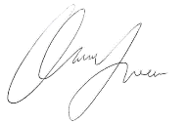

Review Date

